28th September 2020

READING BOOKS

Dear Parents and Carers,

As you will be aware, your child has brought a reading book home today, for the first time this term. This is because we have reviewed our Covid-19 procedures and risk assessments and are now able to put a system in place in order to quarantine books before and after they come home to you.

In order to ensure that this system works, and that we are therefore able to continue to send books home, we ask all parents to ensure that books are returned to school on FRIDAYS only, for them to be quarantined over the weekend and then redistributed the following week. Children must not bring their books in to school with them on any other days.

Please ensure that children read their books at home with an adult throughout each week, discussing the content of what they are reading and practising new words.

Thank you for your continued support.

Yours sincerely,

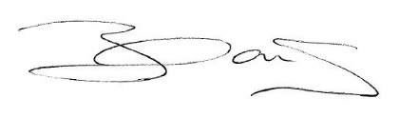
Miss C Nock

