2nd July 2020

Dear Parents,

Summer Holidays July 21st – 1st September
As you know, there has been a lot of information shared in the press over the last few weeks about the possibility of schools being open for children during the Summer holidays.

I am writing to let you know that, at Tame Valley, we feel it is important for our children and staff to have a Summer break, as they usually would. Therefore, Tame Valley will NOT be open for children during this period.

Children will break up for the Summer holiday on Friday 17th July 2020. The 20th July is an INSET day.

Wider Opening from September 2020

Detailed guidance has, today, been issued by the DfE in relation to bringing all children back to school safely in September.

We are working hard in school and across the MAT to put plans in place for this. As soon as I am able to, I will confirm with you the details around what this will look and feel like for you and your children. As always, the health, safety and wellbeing of everyone will be at the heart of all our plans.

In the meantime, continue to take care of yourselves and your families.

Yours sincerely
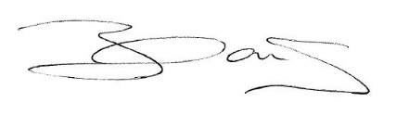
Miss C Nock

Headteacher

