What to do today

1. Make notes about a character
- Make notes on Shane that show what you know about this character. You could include questions that you have about him as well.
- Listen to the story again https://www.youtube.com/watch?v=rjzP18bsSdQ and add to your notes as you do.

2. Look closely at an illustration
- Look at the Last Page of the book.
- Read Picture Prompts and think about your answers.
- Choose five of your answers to write as sentences.
- Complete Objects. Imagine how Shane got each of these objects and why it might be important to him.

3. Imagine interviewing Shane
- Think of 5-10 questions that you would like to ask Shane.
- Write these down and then imagine his answers to each of them. Write his answers, trying to make them sound like the way he talks in the book.

Well done. Explain your ideas about the objects to a grown-up. Show them the answers that you have imagined for Shane too.

Try these Fun-Time Extras
What would you choose if you could have seven objects around you? Draw or photograph the objects and write about why they are important to you.
Interview some other people to find what objects they would choose and why.

Shane

Last Page
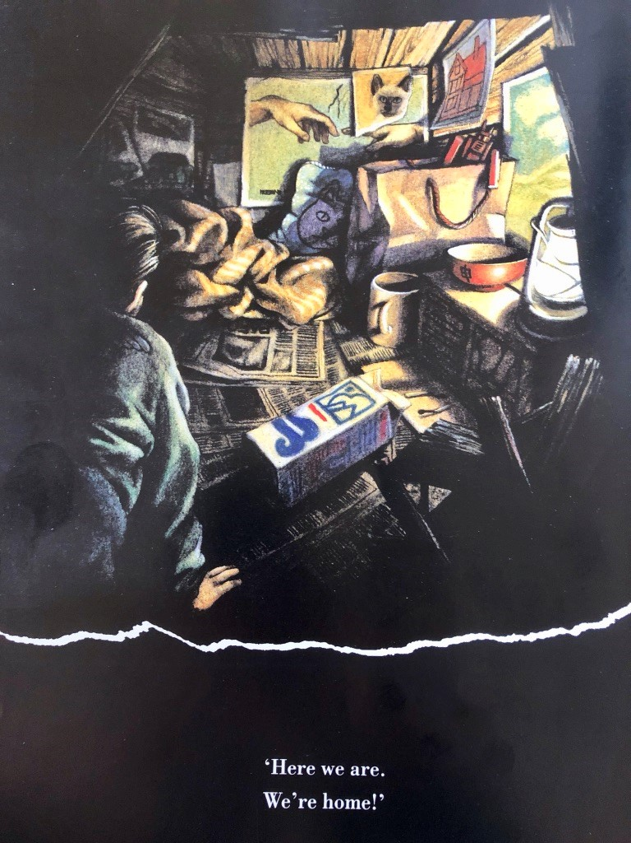

Picture Prompts

- What was your first reaction to this artwork? Why do you think you had the reaction?
- Describe the lines in this artwork
- Describe the colours in the artwork
- Which area of the artwork is most important? Why?
- What adjectives would you use to describe this artwork?
- What verbs would you use to describe this artwork?
- If you could ask the artist a question, what would you ask him/her?
- What emotions do you notice in the artwork?
- Who do you know that would really like this artwork? Why would they like it?
- Who do you know that would really dislike this artwork? Why would they dislike it?
- If this artwork were music, what would it sound like?
from https://artclasscurator.com/82-questions-to-ask-about-a-work-of-art/

Objects
Object | How he may have got it | Why it might be important
Picture of a cat
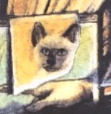
Picture of a house
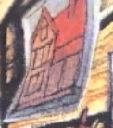
Michelangelo – Creation of Adam picture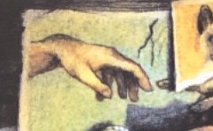
Chinese bowl
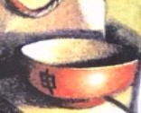
Milk carton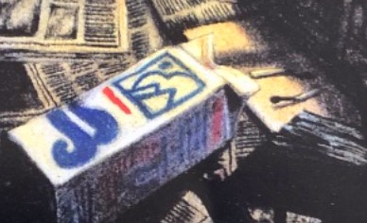
Hurricane Lamp
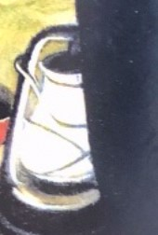
Picture of a green Jaguar

Questions for Shane
Write down 5-10 questions that you would like to ask Shane.
Shane’s Answers
Imagine Shane’s answers and write them here.

