What to do today

1. Listen to a story
- Listen to the Reading of the second part of Way Home, start the video at 6.14, where you ended it yesterday https://www.youtube.com/watch?v=rjzP18bsSdQ.
- Did the story end as you predicted? What could happen in a sequel to the story?

2. Revise informal language
- Use the PowerPoint on informal language or, if this is not possible, remind yourself using the Revision Card about this.
- Complete Formal and Informal.

3. Now for some writing
- Read Through the Windows. This is what Shane says to the cat as they look through the three sets of windows in the book.
- Look at Windows. Pick one window and imagine what Shane would say to the cat about it. Write 2 or 3 sentences of speech, making sure that you keep to Shane’s informal style.
- Challenge yourself to write about the other windows or to imagine and write about other windows.

Well done. Show your writing to a grown-up. Show them the informal features that you have included in Shane’s language. You can look at possible answers to Formal and Informal at the end of this pack.

Try the Fun-Time Extra
Can you imagine Shane coming to your school? What might he say in the classroom, in the playground, to your friends and to your teacher? Write some of your ideas.

Revision Card – Informal Language

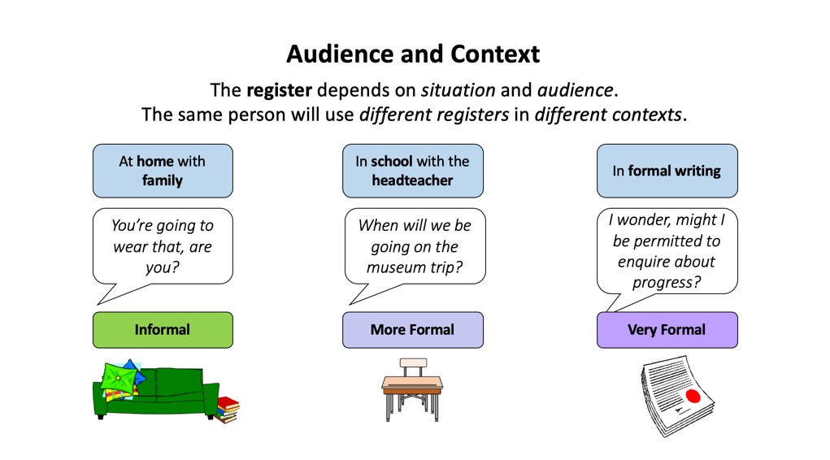 | 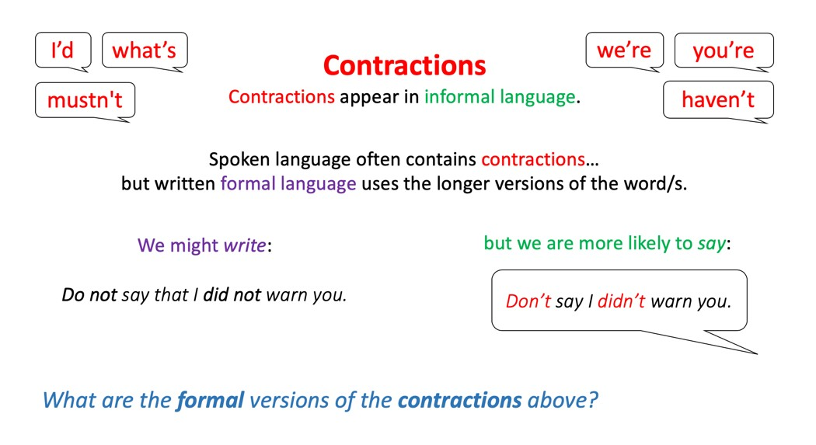
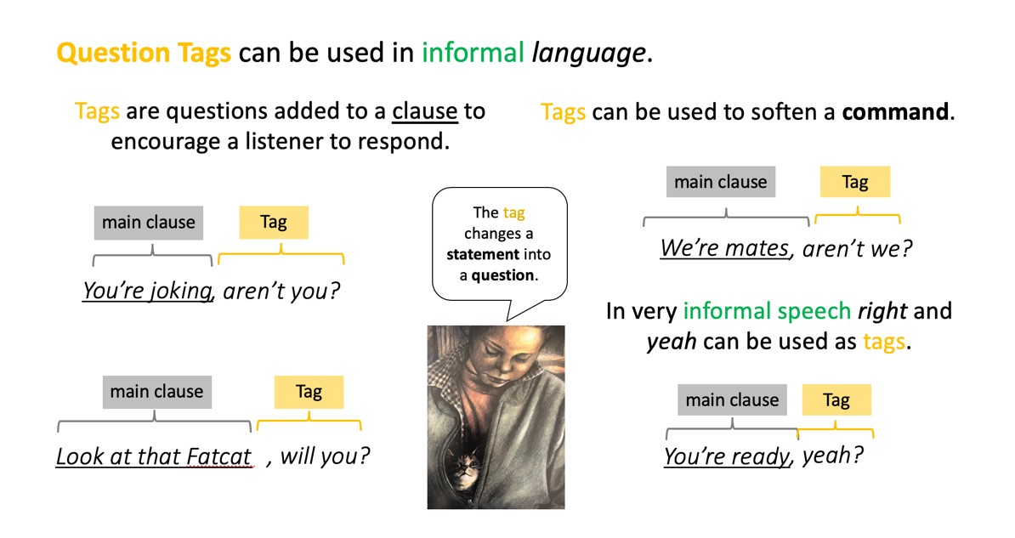 | 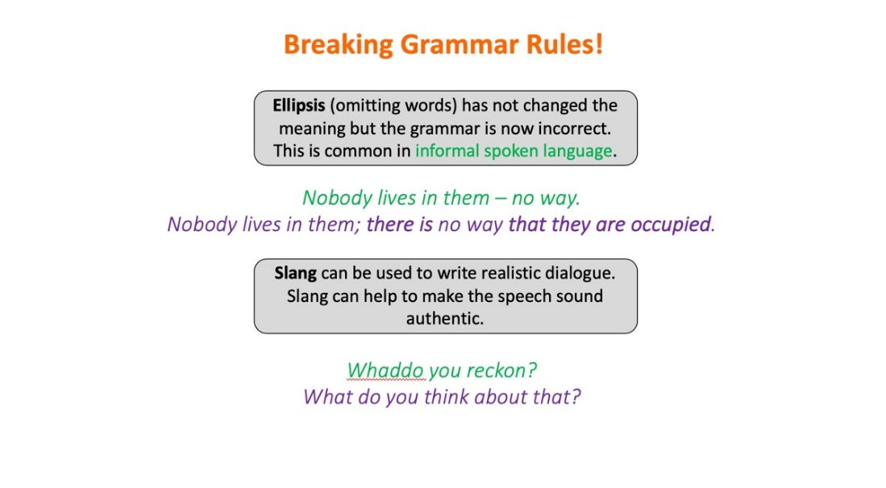

Formal and Informal
Annotate these sentences to show any informal features. Rewrite them in a formal style.
(Informal features: vocabulary, question tags, contractions, slang, ellipsis)

“Whaddo you reckon, Catlegs?”

“Take a look at that Fatcat, will you?”

“You’n me together.”

“Act kinda cool. Cool, right. That’s us.”

“Uh, oh, they’re coming. Gotta get out of here. Away from them.”

“You and me in a Jag. Vroom vroom.”

“We gotta go down right now.”

“But we got each other, right?”

Through the windows

The other cat
“Take a look at that Fatcat will you? I’m telling you that cat’s a loser. Eats fancy mince, no kidding. Heaps of it. Right there at the window. Disgusting. And get that collar. What a joke!”

Car showroom
“You can come out now Whiskettes.
No worries. Hey, just take a look.
Vroom vroom. You and me in a Jag. Vroom vroom.
Huh, but they’ve only got red…and we want green.”

Chinese restaurant
“See they cook stuff right on the table in front of you.
Stacks of meat and things.
But don’t get ideas, Hungry.
No pets allowed, places like this.”

Windows
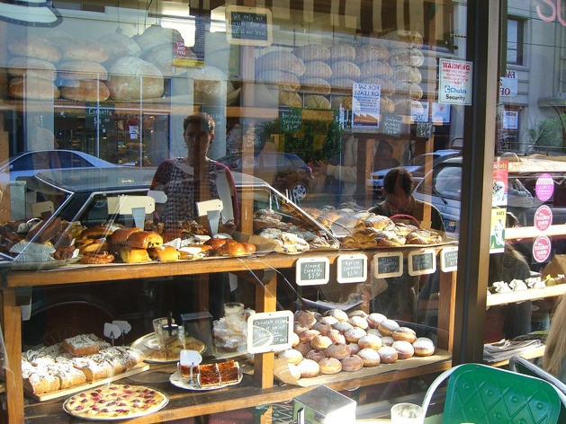

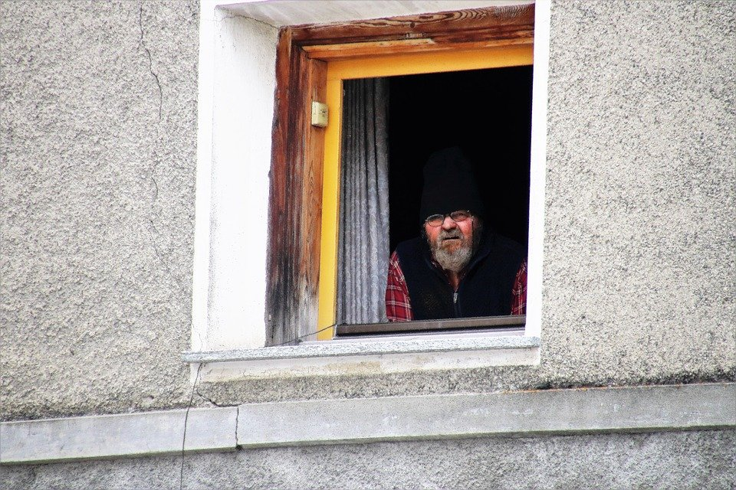

Through the Window
Write your speech for Shane here.

Formal and Informal – Possible Answers
Annotate these sentences to show any informal features. Rewrite them in a formal style.
(Informal features: vocabulary, question tags, contractions, slang, ellipsis)

“Whaddo you reckon, Catlegs?”
What is your opinion, Catlegs?
“Take a look at that Fatcat, will you?”
Please look at the fat cat in the window.
“You’n me together.”
We are united.
“Act kinda cool. Cool, right. That’s us.”
Behave causally as that would be our typical style.
“Uh, oh, they’re coming. Gotta get out of here. Away from them.”
I am concerned that the hostile group are approaching and believe that it is important for us to depart rapidly.
“You and me in a Jag. Vroom vroom.”
I am imagining driving in a Jaguar car with you. I think we would enjoy the sound and power of the engine.
“We gotta go down right now.”
We have to go down immediately.
“But we got each other, right?”
We are able to look after one another.

