What to do today

1. Read about experiences of racism
- Read My Experience – Asim Chaudhry.
- Fill in the column for Asim on Experience Summary.
- Now read My Experience – Claire Heuchan.
- Fill in the column for Claire on Experience Summary.

2. Present a story in words and pictures
- Watch Balraj’s Story:
https://www.bbc.co.uk/newsround/49613514
- Use words and pictures to summarise Balraj’s Story.

3. Read about challenging racism
- Work with a grown-up to read How can you challenge racism? written by Claire Heuchan.
- Discuss what you have read with the grown-up. Which of these ideas is most relevant? How does challenging racism make you feel? Nervous, hopeful or a bit of both?

Well done. Talk to a grown-up about what you have learnt today.

Try this extra activity
Can you make a presentation of Asim or Claire’s story (or both), using words and pictures?

My Experience
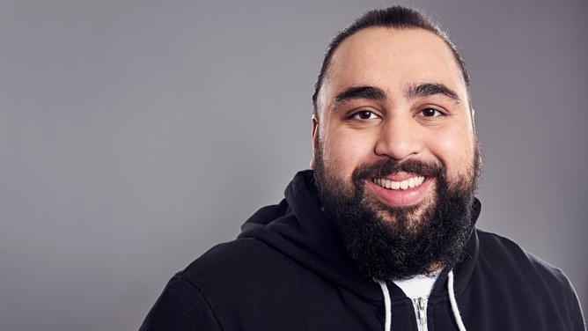

by Asim Chaudhry
Just a headache
It was the summer of '98. I was 11 years old. The World Cup was on and I was at my local park in Feltham, West London, playing football in my new football boots with my best friend, Asad. Before I share this experience let me give you some context about what football meant to us when we were kids. It was our life!
In the morning on the way to school we would kick the ball to each other, at times it would go on the road and we would get shouted and beeped at by angry morning commuters.
At school I would stare at the clock, waiting for lunchtime, choreographing the perfect goal, doing the commentary in my head and everything! “It's a perfect cross from the left wing whipped in by Asad Khan, Asim Chaudhry brings it down expertly with his chest, he flips it over the defender with a gravity-defying move, the goalkeeper rushes out and Asim lobs him with a bicycle kick — this is the greatest goal of all time!! Take a bow son!”
The bell for lunch would snap me out of my footballing daydream. I would sprint to the back field to have a quick five-a-side. I would try to emulate Ronaldo! I tried to do step-overs and take elaborate long-distance free kicks with the outside of my boot like Roberto Carlos would. The ball would rocket 100 miles into the sky! I didn't care, it was the theatre of it all that gave me the pleasure. We would come back from lunch, covered in mud with ripped trousers. After school we would head straight to the park and do it all again, then go home and watch it on TV; we were CONSUMED by it! When I was playing football nothing seemed to matter, not my parents' imminent divorce, my cousin's battle with cancer, the racist kids around my area who would chase me home, nothing. It was pure escapism. My dad worked as a mini cab driver and I would bug him about these new Nike Ronaldo boots that I wanted. I promised to do extra chores and even clean his car every weekend. Then one day he told me he worked all night, saved up some money and then presented me with football boots. I. WENT. WILD. I started running around the living room in a state of pure euphoria.
So back to my experience. I was with Asad in the park, wearing my new boots. Asad had just bought a brand new official France '98 World Cup football and we were practising penalties. I heard a voice, “Let me have a shot mate.” It was the racist kids from my area; they were holding golf clubs. We ignored them. The main one said “Oi Mowgli, I'm talking to you, don't mug me off, just one shot”. Asad gave me a look like 'maybe they'll leave us alone if we comply', and he passed them the ball. “Thank you, come again,” the main one said in an 'Apu from the Simpsons voice'. He faked a shot, then picked up the ball and started walking away. “Come on man, he just bought that,” I said in a rather meek tone. Asad gave me another look, this time it was more of a 'please shut up Asim, let them have it' type of look.
These boys were much bigger and older than us. The main one with the ball came up to me and said “You want your ball back?” He called me a racist name and swore. He kicked the ball square in my face and then punched me in the head. My face felt warm, I fell over, all I could hear was laughter. I felt my nose, blood, warm blood.
Asad ran over to me, the boys left, with the ball. We went to the shop and got someone to buy me paracetamol. I remember I had a headache, it was painful. My head felt heavy but I also felt something else. It was shame. We just got robbed and attacked and there was nothing we could do about it. The lack of power left shame, real, crippling shame. I wiped away my blood and didn't tell anyone about what had happened. I've been called racist names before as I lived in a very racist area but this was the first time I was attacked right after being called names. The punishment for being brown felt so much more instant and real! My heart was racing and my head was still pounding.
I went home and didn't really want to watch the football, I still had a headache. I put my Ronaldo boots in my cupboard.
The next morning, I told my mum I couldn't go to school because I had a headache. She checked my temperature and told me to stop messing about and get ready for school. I started crying and begged her to let me have the day off, “Please mum, my head.” Knowing it was something else, my mum asked me what was wrong. I wanted to tell her but I couldn't, the shame crippled me. “Nothing,” I said. “Just a headache.”
Asim Chaudhry is a comic actor who has won a Royal Television Society Award and been nominated for two BAFTAs.

Adapted from What is Race? Who are Racists? Why Does Skin Colour Matter? And Other Big Questions by Claire Heuchan and Nikesh Shukla

My Experience
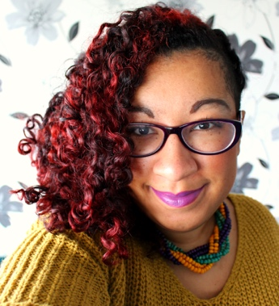
by Claire Heuchan

I grew up black, which is pretty normal — millions and millions of people around the planet do. What's less typical is that I grew up as the only black person in an otherwise white family. In many ways I was very lucky as a child, because I was always surrounded by love. I have so many good memories of being a kid: my mum taking me on weekly adventures to the library, going to the swimming pool with my grandparents on holiday, getting my first pet (a sweet, chubby hamster called Rose). But it was lonely, being a different colour from all of my family and most of my friends. Their experiences were different from mine in hundreds of small ways, and quite a few bigger ones.
There were a lot of things that my family, even though they loved me very much, couldn't protect me from. As a kid I understood that there were these awkward, painful moments that happened to me but not to white children — I knew those moments had something to do with the colour of my skin and the texture of my hair.
Every so often, an adult would ask where I was from originally. Even though I've lived in Scotland since I was born, they couldn't have been more surprised if I'd said: 'You've caught me — planet Mars is where I'm really from.' Nobody was very curious about where my mum came from, never mind where she lived 'before here'. I dreaded these moments, and my stomach twisted into knots when I felt that question coming.

Security guards were also interested in me, even though the rest of my family escaped their notice: they stopped me in airports when everyone else went on ahead. My family would linger, waiting for a stranger to finish patting down my body, and shame clouded over my excitement about the holiday.
I'd fold into myself as hairdressers argued over who had to cut my hair, telling me that I'd look a lot prettier if it was straight. Learning that a group of parents called me 'that cheery coloured girl' came as a shock — plenty of worse names were used in the playground, but somehow I'd thought adults would know better. If I live to be one hundred, I'll never forget the deep humiliation of a boy telling me my brown skin was the exact same colour as poo.
As a kid I never challenged behaviour I now know is racist. It made me anxious in ways I didn't know how to put into words without that volatile mix of anger and sadness leaking out. There was an idea that I had to be on best behaviour, because if I misbehaved then people would think all black children were naughty. Even then I knew that none of the white children were expected to act like little ambassadors for all white people — they were just allowed to be themselves, which meant being naughty sometimes.
My family didn't know how to explain racism to me. I think, like a lot of white people, they didn't give much thought to racism because it didn't do them any harm. And I didn't have the language to explain something they had never experienced. No matter how close we were, it felt like I was living in one world and they were living in another.

Claire Heuchan is a blogger and writer
Experience Summary

 | Asim | Claire
Interests as a child
Experience of racism
How racism made them feel
How you feel reading their story

Balraj’s Story
https://www.bbc.co.uk/newsround/49613514
Use words and pictures to summarise Balraj’s story

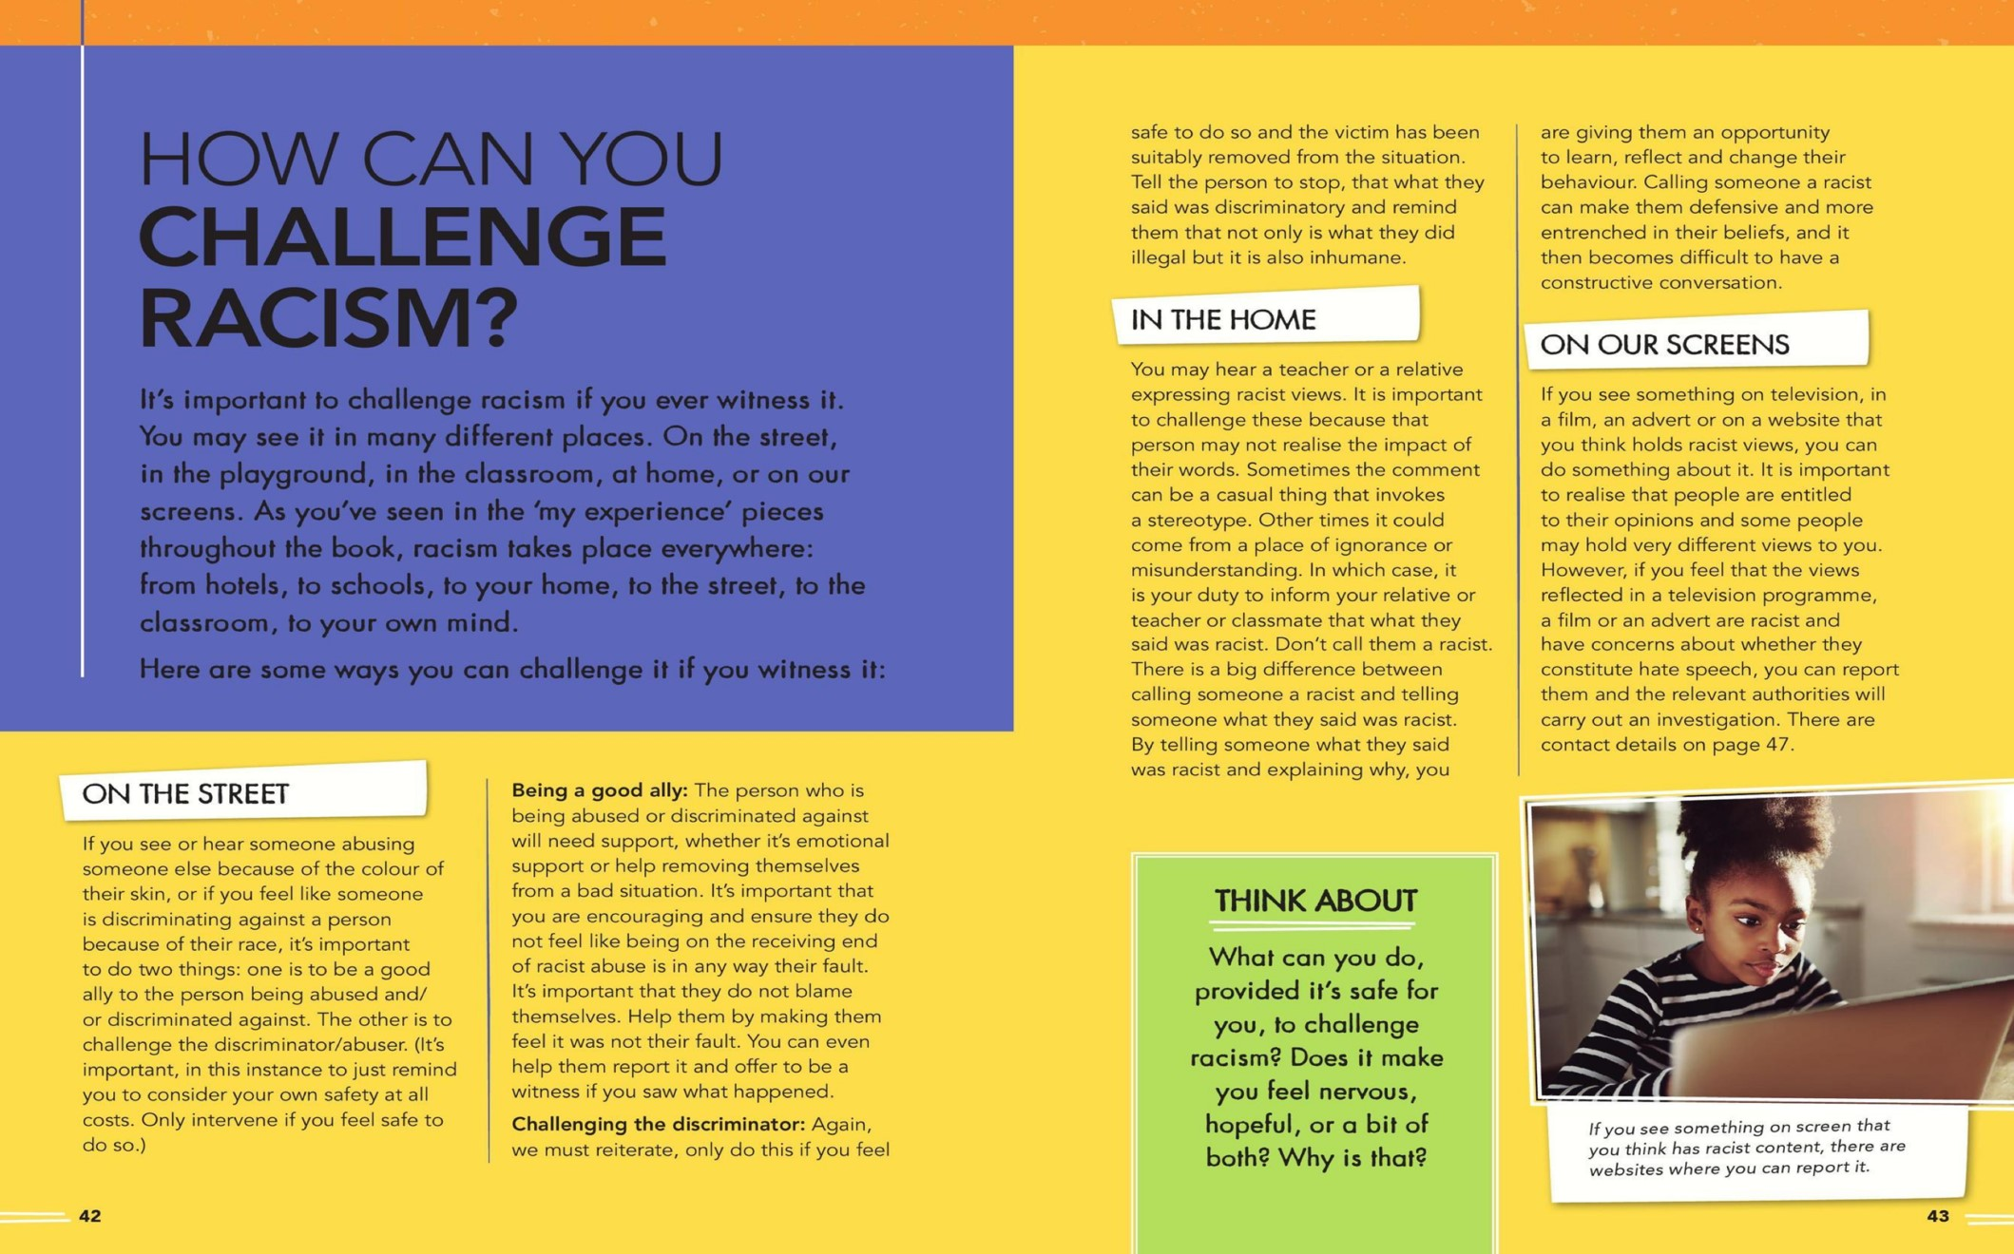
From What is Race? Who are Racists? Why Does Skin Colour Matter? And Other Big Questions by Claire Heuchan and Nikesh Shukla
Websites on page 47 are: asa.org.uk and Ofcom.org.uk

