What to do today

1. Look closely at a picture
- Look closely at Game Changer by Banksy. This artwork was revealed in Southampton Hospital.
- Read Picture Prompts and think about your answers. Write them as clear sentences.

2. Remind yourself about relative clauses
- Use the PowerPoint on Relative Clauses or, if this is not possible, remind yourself using the Revision Card.
- Complete Relative Clause Activities.

3. Now for some writing
- Look at Street Art Examples 1 and 2.
- Write sentences that include relative clauses about these pictures. Try to make some of your relative clauses embedded with some following the main clause.

Well done. Show you sentences to a grown-up. Can they work out which piece of street art each sentence is about? Show them the relative clauses that you written.

Try these Fun-Time Extras

- Find out more about Banksy and Street Art.
- Look at Slogan Examples. Invent a slogan for your family and friends. Make a design that shows your slogan clearly.

Game Changer

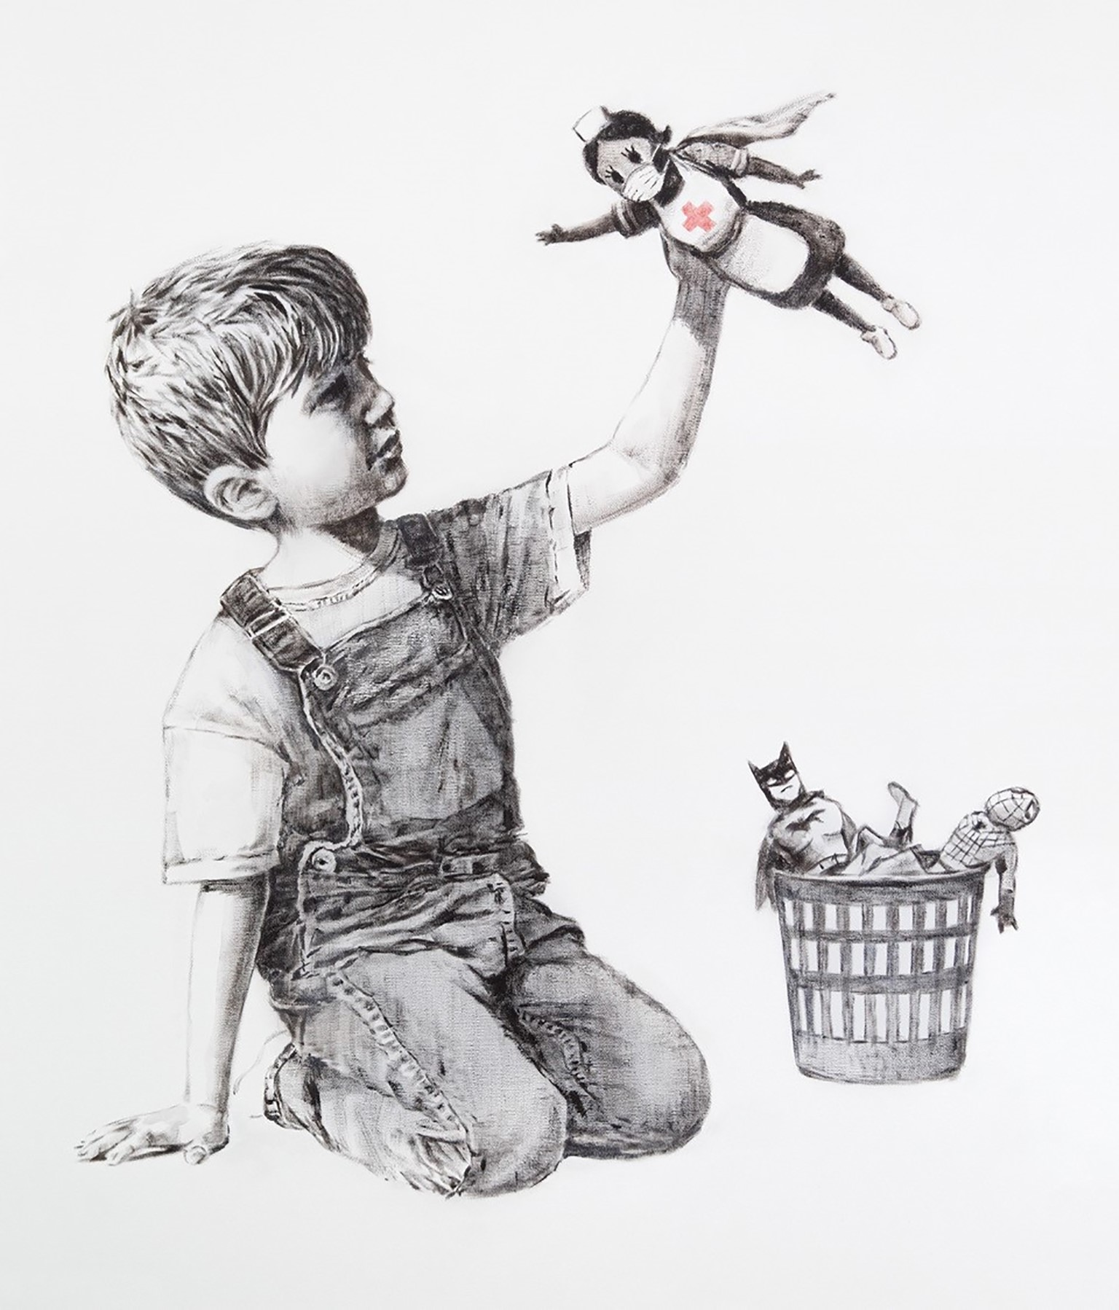

@banksy/Instagram/PA Wire
Picture Prompts

- What was your first reaction to this artwork? Why do you think you had the reaction?
- Describe the lines in this artwork
- Describe the colours in the artwork
- Which area of the artwork is most important? Why?
- What adjectives would you use to describe this artwork?
- What verbs would you use to describe this artwork?
- If you could ask the artist a question, what would you ask him/her?
- What emotions do you notice in the artwork?
- Who do you know that would really like this artwork? Why would they like it?
- Who do you know that would really dislike this artwork? Why would they dislike it?
- If this artwork were music, what would it sound like?
from https://artclasscurator.com/82-questions-to-ask-about-a-work-of-art/

Revision Card - Relative Clauses

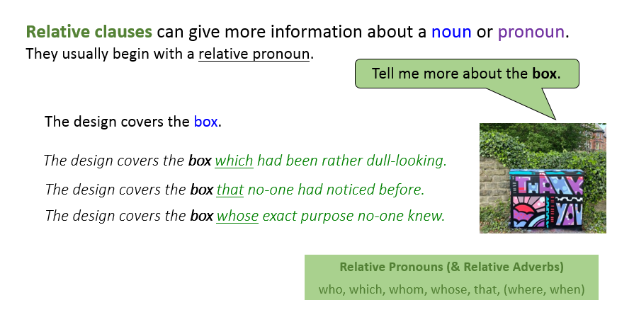
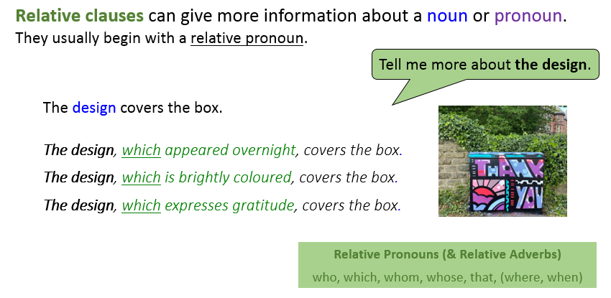

Relative Clause Activities

1) Add a relative clause to each of these sentences.
Look at the pronouns in the box and try to use a different one each time.
E.g. At his house, he has a bat cave which is very well equipped.
Relative pronouns
which
who
where
when
whose
that
He is holding a toy nurse ….
He is, most likely, a boy…
He wears a pair of dungarees…
He has left his other toys….

2. Embed a relative clause in the following
sentences. You could use one of the clauses
from the box at the bottom.
This picture, …, was left in Southampton Hospital.
Banksy’s artwork, …., commands a high price at auction.
Nurses, …, have been praised for being heroes.
The title of the picture, …. , is a play on words.
The only colour in the picture, …, shows her importance.
Banksy, …., gave his picture for free.
whose identity is a mystery
which is ‘Game Changer’
whose working conditions are often hard
which is well-known worldwide
which celebrates the NHS
which is the red cross on the nurse’s uniform

Street Art Examples 1

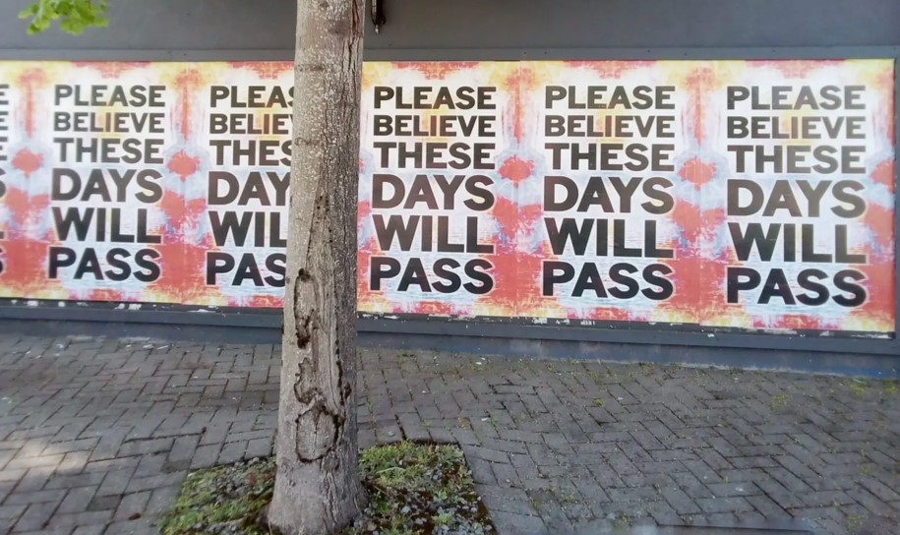

Street Art Examples 2

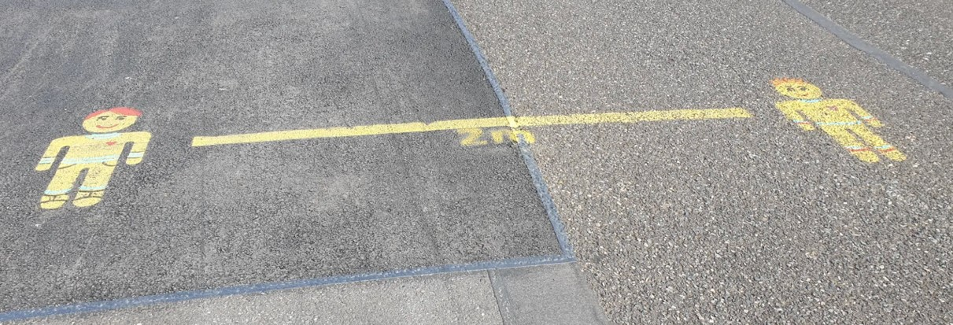
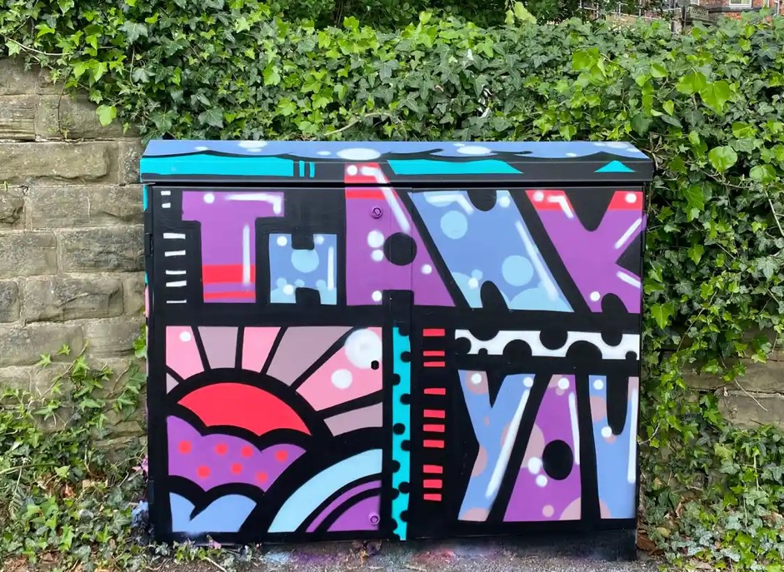

Street Art Sentences

who
which
whom
whose
that

Write sentences with relative clauses about the Street Art examples.

Show your sentences to someone else. Can they guess which piece of art each sentence is about?

Slogan Examples

