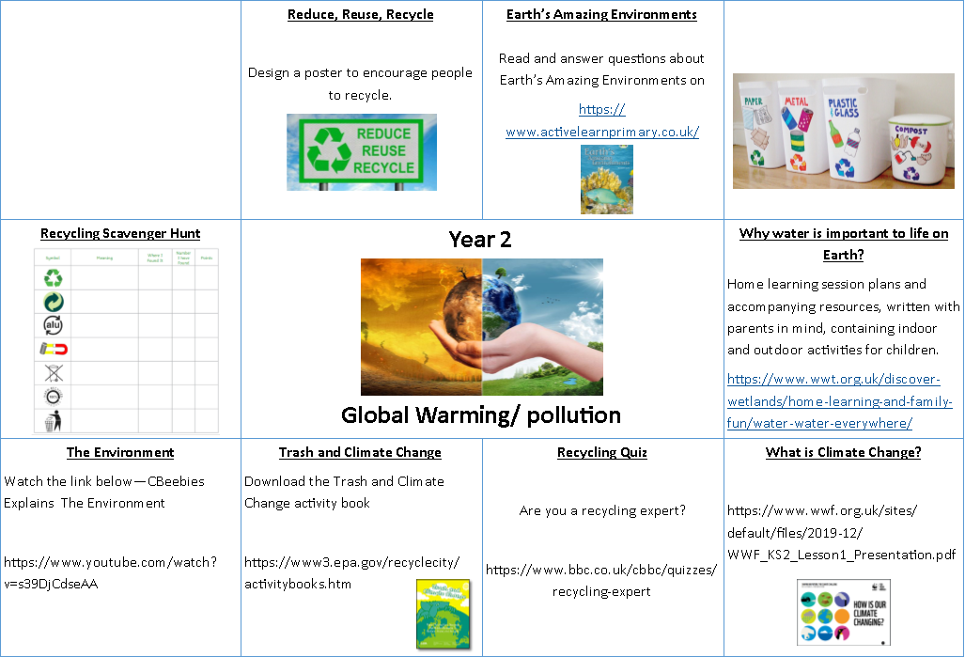

**Recycling Art Projects**

Have a go at these cute art projects and create colourful decorations for the garden.

https://cleanriver.com/recycling-projects-kids-schools/