An Adventure in Space
Today you are going to write a story opening using the picture.
- Use your adjectives from Day 1 to describe what you can see.
- Use your character descriptions from Day 2 to describe your characters.
- Use your answers from Day to help build your story.

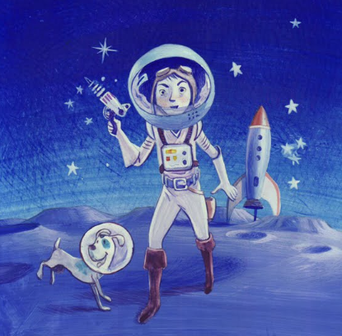

You can use the following starter to help you:
James and his dog Shadow stepped out of their magnificent, shiny rocket. They saw hundreds of stars twinkling around them in the blue sky. They were excited about what they might find on their adventure into Space.

Remember our rules for writing a sentence:
- Think of your sentence.
- Practise saying your sentence aloud until you can remember it.
- Write your sentence down. Remember to Fred talk each word.
- Start your sentence with a capital letter.
- Finger spaces between every word.
- A full stop at the end.
- Read over your sentence to check it makes sense.

