Space
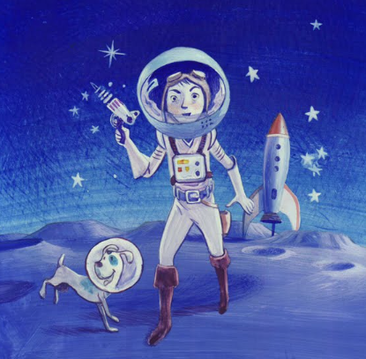
Write different adjectives in the box to describe the picture.

