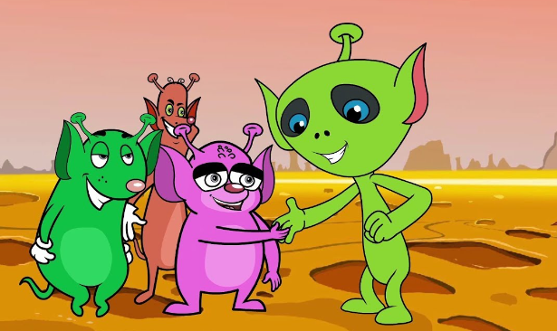
Using ‘and’

Today you are going to use your sentences from day 2. You will need to use the word ‘and’ to join two sentences together.

For example:
The alien is short. The alien has pointy ears.
The alien is short and has pointy ears.

Remember our rules for writing a sentence:
Think of your sentence
Practise saying your sentence
Fred each word when you are writing
Start your sentence with a capital letter
Remember your finger spaces
Remember your full stops.

