Summer
Use the pictures to help you think about the summer. What things do you do when it is summer? Where do you go? What do you eat when it is really hot outside?

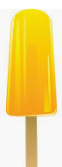
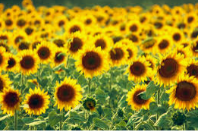
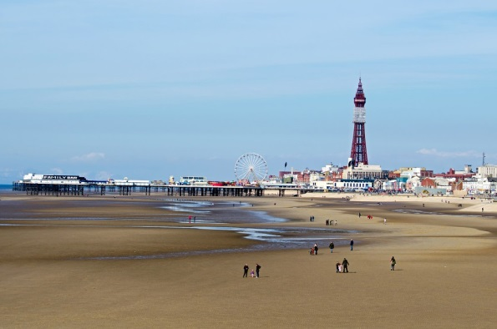

Today you are going to use adjectives to describe the things that remind you of summer. For example, delicious ice cream, soft sand.

