English
Reading
At Tame Valley Academy we strive to develop a love of books and reading. Reading is a huge part of school life as we believe it is central to developing children’s understanding in all areas of the curriculum. Each class spends at least 15 minutes a day sharing a book to develop a culture of reading for pleasure.
We are fortunate enough to have an exciting school library with a variety of fiction and non-fiction books covering all genres and topics. All classes access the library weekly as a class to share books together and individually.
The youngest children in our school share books daily and discuss the stories that they have read. From Year 1 to Year 6 we teach Guided Reading with a range of activities which include work on vocabulary and comprehension. The children also read with adults and have time to develop a love of reading. The children focus on a text or extract; analyse the vocabulary; carry out further research into the text; use VIPERS to answer comprehension skills; and really develop their understanding of the text. Our children really enjoy their reading lessons!
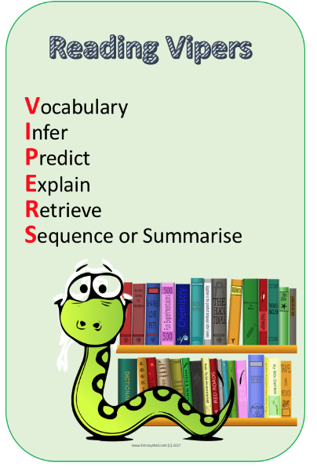
Writing
At Tame Valley Academy we use Talk for Writing to develop children’s writing skills. Talk for Writing is an engaging teaching framework developed by Pie Corbett, supported by Julia Strong. It is powerful because it is based on the principles of how children learn. It enables children to imitate the language they need for a particular topic orally, before reading and analysing it, and then writing their own version.
From Nursery through to Year 6, children share exciting stories and develop their understanding of a particular topic. During the Imitation Phase children explore the story through oral retelling, actions and story maps. Through the Innovate Phase children have the opportunity to develop the story through changes as whole class. Finally, during the Independent Application Phase, children create their own version of the story allowing them to be creative and effective writers applying the skills they have learnt.
