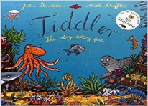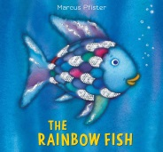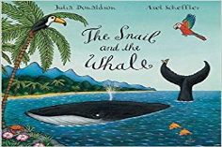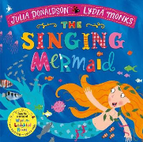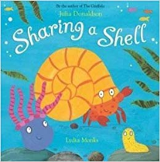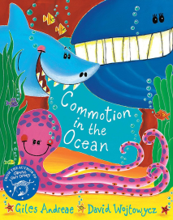

**Literacy**

* Draw a fish and describe it.
* Tiddler is always late! Complete the sentence. ‘Sorry I’m late …’
* Sea Life Fact Files. Draw some sea creatures and write some facts about them.
* In the snail and the whale, the snail is small and the whale is big. Can you write a list of other words that mean small and big?
* Make a wanted poster for a pirate.
* Write a postcard from your holidays.
* Make a list of items you would pack in your suitcase for your summer holidays.

**Maths**

* Play a fishing game. Can you subtract the fish and see how many are left in the pond?
* Draw 2 ponds. Can you share the fish equally between the 2 ponds?
* Tiddler is always late – can you tell the time on the clocks?
* Use water play to explore capacity (full/empty/half-full)
* Can you write numbers 1-20 on the shells/fish and put them in the correct order?
* Can you order the sea creatures in order of size?
* Go on a treasure hunt for some pirate gold using directions/positional language.
* Can you add the pirate gold coins?
* Use coins to buy ice creams. What coins have you used?
* Counting ice cream scoops in 2’s.
* Make a tally chart to find the most popular ice cream flavour in your family.

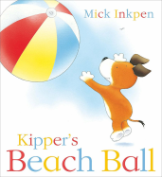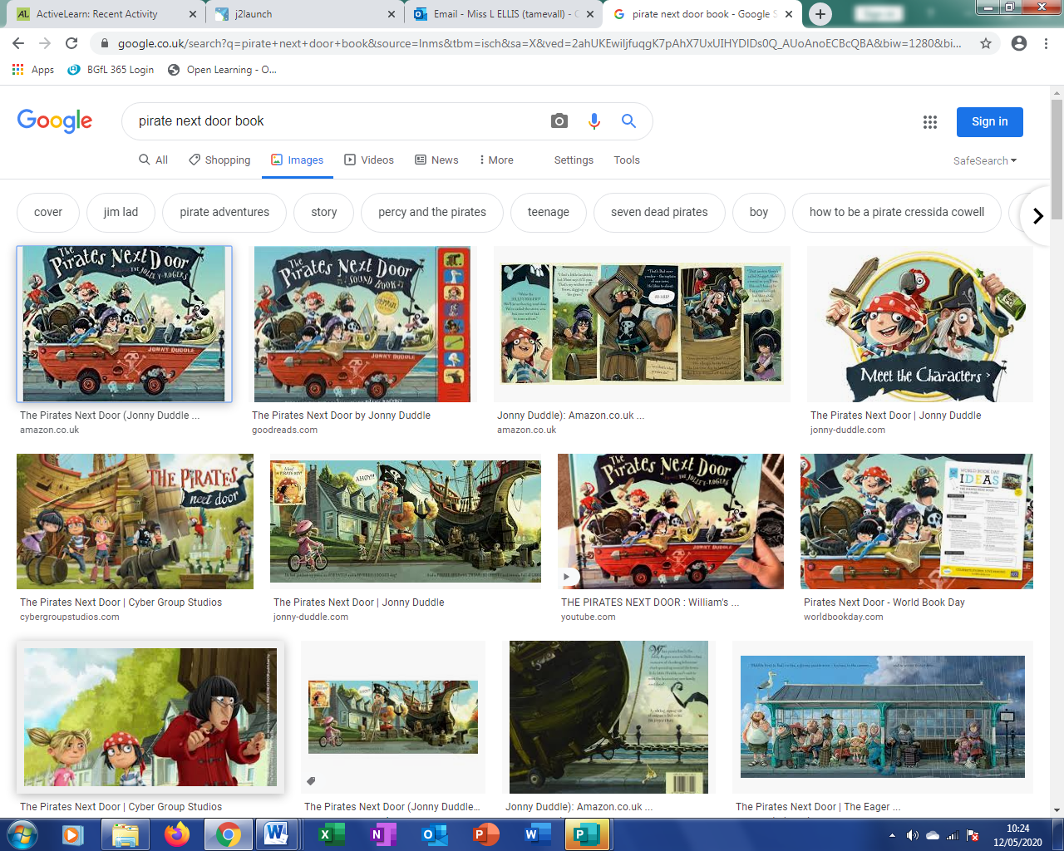

**The Sea**

**Reception**

**Summer 2 Activity Ideas**

**Physical Development**

* Practise throwing and catching a beach ball/Frisby.
* Try out some sports day races with your family e.g. running/egg and spoon/sack race.
* Try some Cosmic Kids Yoga: Popcorn the pirate/Mimi the Mermaid/squish the fish/Tommy the Turtle/Norris the Seahorse/Moana.
* Play the game ‘Captains Coming.’

**Personal, Social, Emotional Development**

* How can we protect ourselves in summer from the sun?
* Who do you go to when you need help?
* Talk about why it is good to share and how to be a good friend.
* We are all different. How are you different from your friends?

**Communication and Language**

* Where is your favourite place to go on holiday and why?
* Play ‘Kim’s game’ with seaside objects. Can you remember all of the objects?
* Who would you ‘share a shell’ with and why?
* Share facts about sea creatures.
* Play ‘Guess Who’ with sea creatures.
* Talk about ways you can look after the environment.

**Understanding the World**

* Label a fish: head, scales, fin, tail, gills.
* Observe sea creatures and their habitats.
* Using water play, experiment with float and sinking.
* Use technology to draw a sea creature on ‘Paint’ or use a computer to research sea creatures.
* Sort rubbish in your home into the different materials e.g. paper/plastic. Talk about the 3 R’s ‘reduce, reuse, recycle.’
* Dress you teddy for summer.
* What is the difference in weather between summer/winter? How do we dress differently? What happens to the trees/flowers in summer/winter?

**Expressive Arts and Design**

* Design and make a rainbow fish.
* Make a pirate prop e.g. a telescope/treasure map/parrot/hat.
* Make a paper plate crab or a sea creature from junk modelling e.g. a star fish, jelly fish, octopus, turtle, whale.
* Make a snail out of playdough.
* Make a kite
* Make an ice cream from junk modelling/design your favourite ice cream.
* Role play an ice cream shop.