The Lost House
Today you are going to write sentences about the picture. Use the following questions to help you.
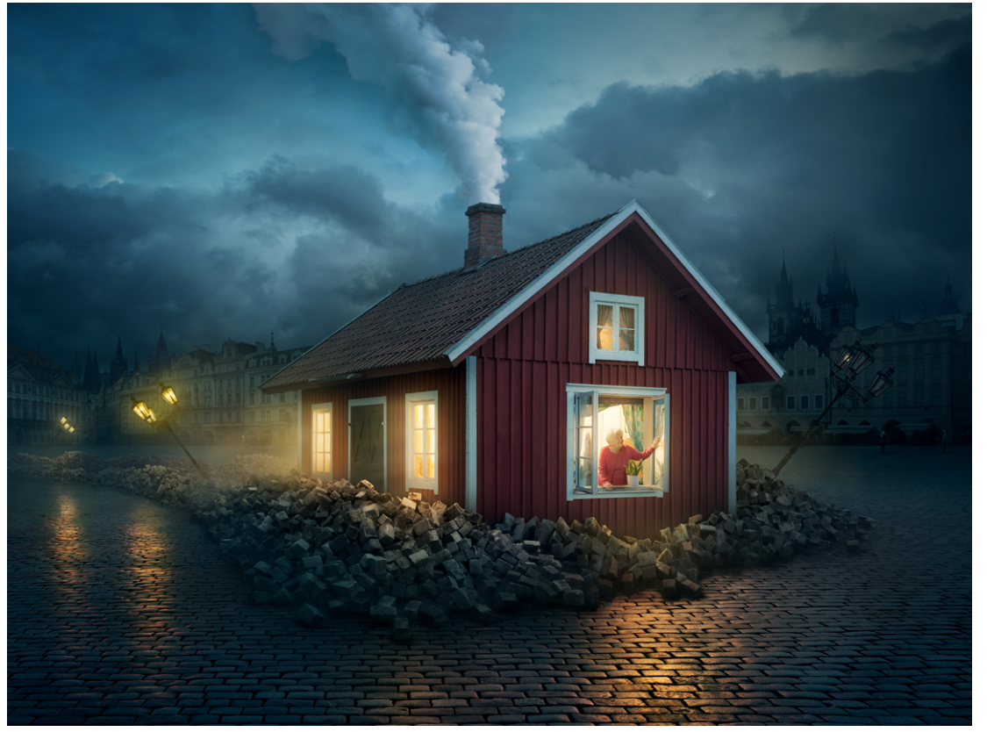
What do you think has happened in this picture? Why is the house here? Who is the person in the window? How do you think they feel about being here? Where do you think this house is?

Remember to include capital letters at the start of the sentence, finger spaces and full stops.

