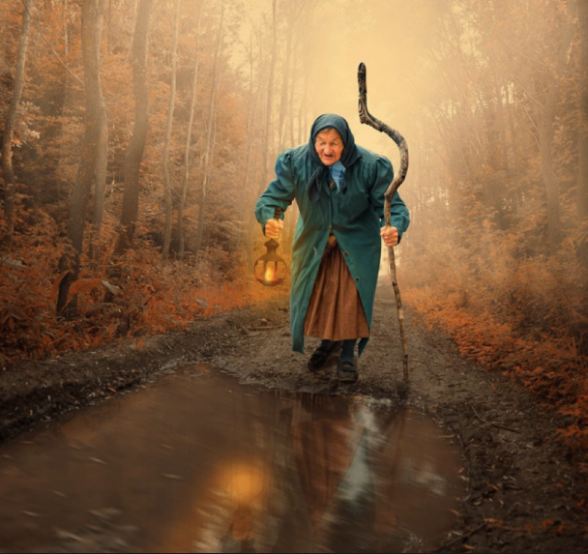
The Lonely Road
You join this lady on her journey. Write a diary entry explaining where you went and what you experienced.
You could visit a magical shop or market, go to a party in the forest or visit the local talking animals. You could visit a scene from yesterday such as the scary cave.
Remember to start off with dear diary, use lots of description to explain your journey and use the past tense as this has already happened.
Use my starter below for help.

Dear diary, today I went on the most magical journey. As I sat on the side on the dark, dusty road I could see a small figure approaching me. It was an old lady. She was using a pointy stick and an old lantern. I asked her where she was going. She told me to join her to find out, so I did…….

