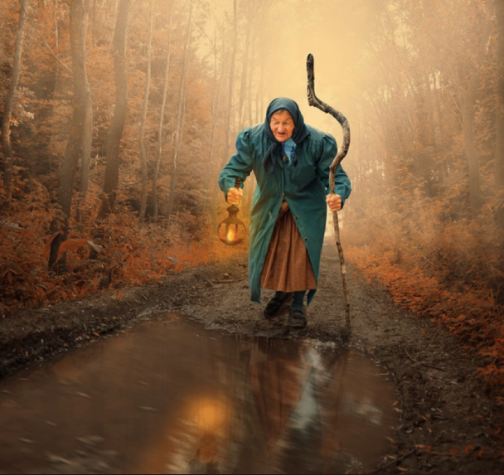
The Lonely Road

You see this lady walking down the dark road. She is alone. The road goes on for miles in both directions. What questions would you like to ask her?
Write a list of questions. You might want to know where she has come from, or even why she has to walk with a stick.

Remember, we need to use questions marks when we ask a question.

