Week Beginning: 22.06.20 | Monday | Tuesday | Wednesday | Thursday | Friday
Focus Book: Snail and the Whale  Reading  Watch the story of ‘Snail and the Whale’ on Youtube:  https://www.youtube.com/watch?v=3ZAtKDaFU6c  Ask the children some questions about the book. | Daily Phonics Lesson: Group A- sound ‘e’ Group B - sound ‘ll’  (see phonics planning for more details).  Practise reading weekly high frequency words:  don’t, do, be. | Daily Phonics Lesson: Group A – sound ‘l’ Group B - sound ‘ss’  (see phonics planning for more details).  Practise reading weekly high frequency words:  don’t, do, be. | Daily Phonics Lesson: Group A- sound ‘h’ Group B – sound ‘ff’  (see phonics planning for more details).  Practise reading weekly high frequency words:  don’t, do, be. | Daily Phonics Lesson: Group A – sound ‘sh’ Group B – sound ‘ue’  (see phonics planning for more details).  Practise reading weekly high frequency words:  don’t, do, be. | Daily Phonics Lesson: Group A – sound ‘r’ Group B – sound ‘wh’  (see phonics planning for more details).  Practise reading weekly high frequency words:  don’t, do, be.
Writing | Think of some other words that mean ‘small’ (Synonyms). Can you have a go at writing some of these words next to a picture of a snail? | Think of some other words that mean ‘big’ (Synonyms). Can you have a go at writing some of these words next to a picture of a whale? | Here are some words that mean ‘small’: tiny, little, minute. Write a sentence where you might use this word, e.g. A very tiny, slimy, snail. | Here are some words that mean ‘big’: giant, large, enormous. Write a sentence where you might use this word, e.g. A large, black and white whale. | Make a save the whale poster.  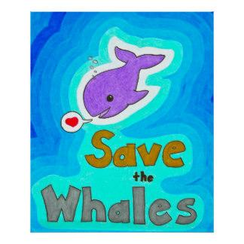
Maths | Make three towers of varying sizes out of Lego. Can your child order the towers by height starting with the smallest and measure each tower using a ruler (or count how many Lego bricks you have used for each tower). | Ask your parent to shout out a number. Can you tell them what is one more than this number? E.g. 8 (1 more than 8 is 9). If you have a dice at home, roll the dice and add 1 more onto the number it lands on. | Addition Number sentences. Remind your child of what the ‘add’ sign looks like. Write the following number sentences for your child. Can they work out the answers? (They can use sweets/raisins/counters to help):  5+3=  2+2 =  7+2 =  9+1 =  6+5 =  8+1 = | Ask your parents to draw some shapes on a piece of paper. Can you cut the shapes out and then cut or fold them in half? | What is half of 10?  What is half of 8?  What is half of 6?  What is half of 4?  What is half of 2?  You can use counters/sweets/raisins to help you?  Challenge: Can you half 7?
Topic: ‘The Sea.’ | Make a snail paper plate picture.  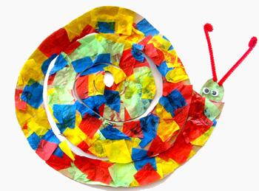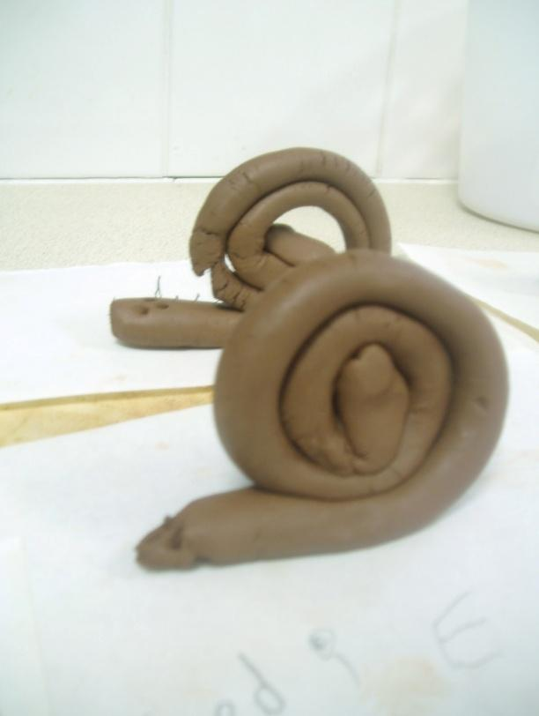  Make a snail out of clay/playdough. | Make a whale paper plate craft. | Moving in a variety of ways – use the music ‘Under the Sea’ from ‘The Little Mermaid’ to move in different ways like sea creatures.  Cosmic Kids:  Popcorn the dolphin  https://www.youtube.com/watch?v=YR1OxBk8BF4 | Talk about ways that you look after the environment E.g. litter picks, watering the plants.  Reduce, Re-use, Recycle – can you ask your parents if you can help sort the rubbish into paper, metal and plastic? | Cosmic Kids Yoga – Tommy the Bedtime Turtle https://www.youtube.com/watch?v=gCLW77sABTc

