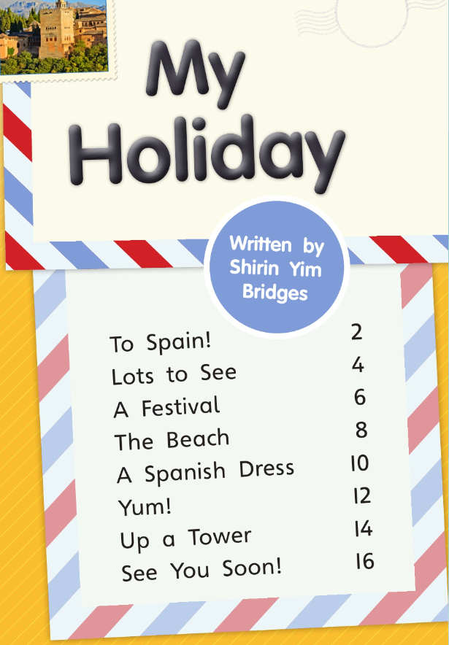

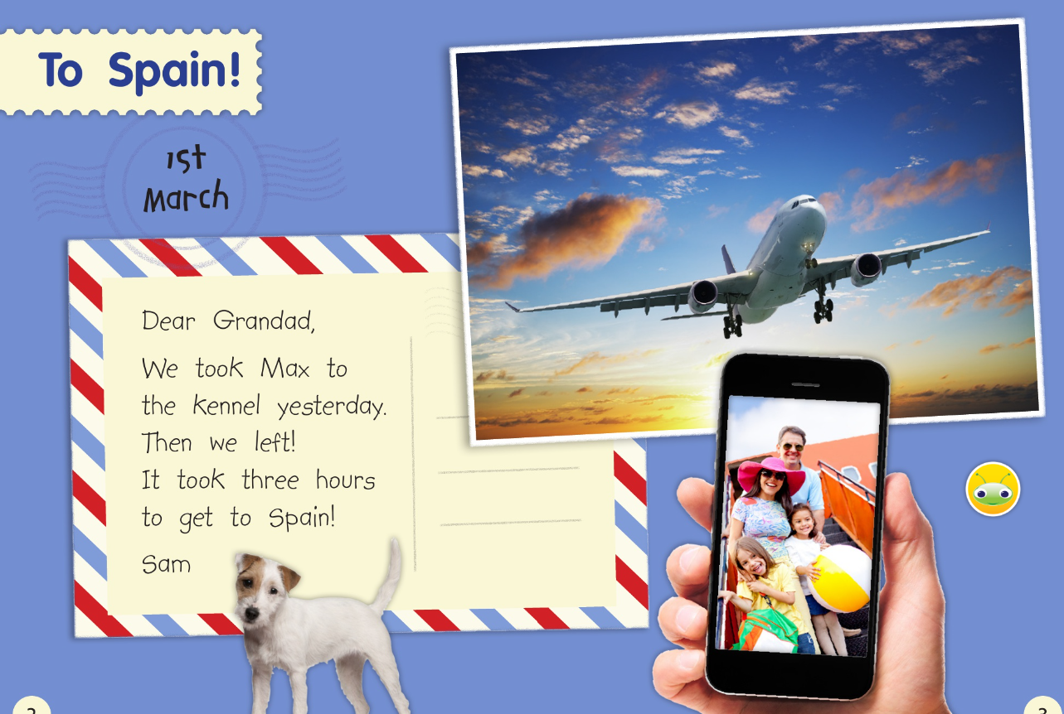

Who did Sam write the letter to?

How long did it take to get to Spain?
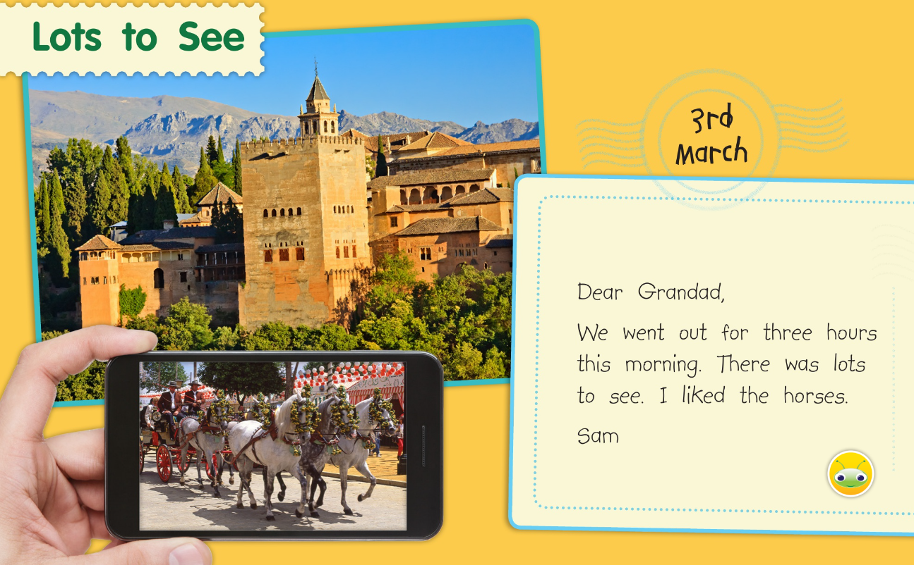

How long did they go out for this morning?
What did Sam like?
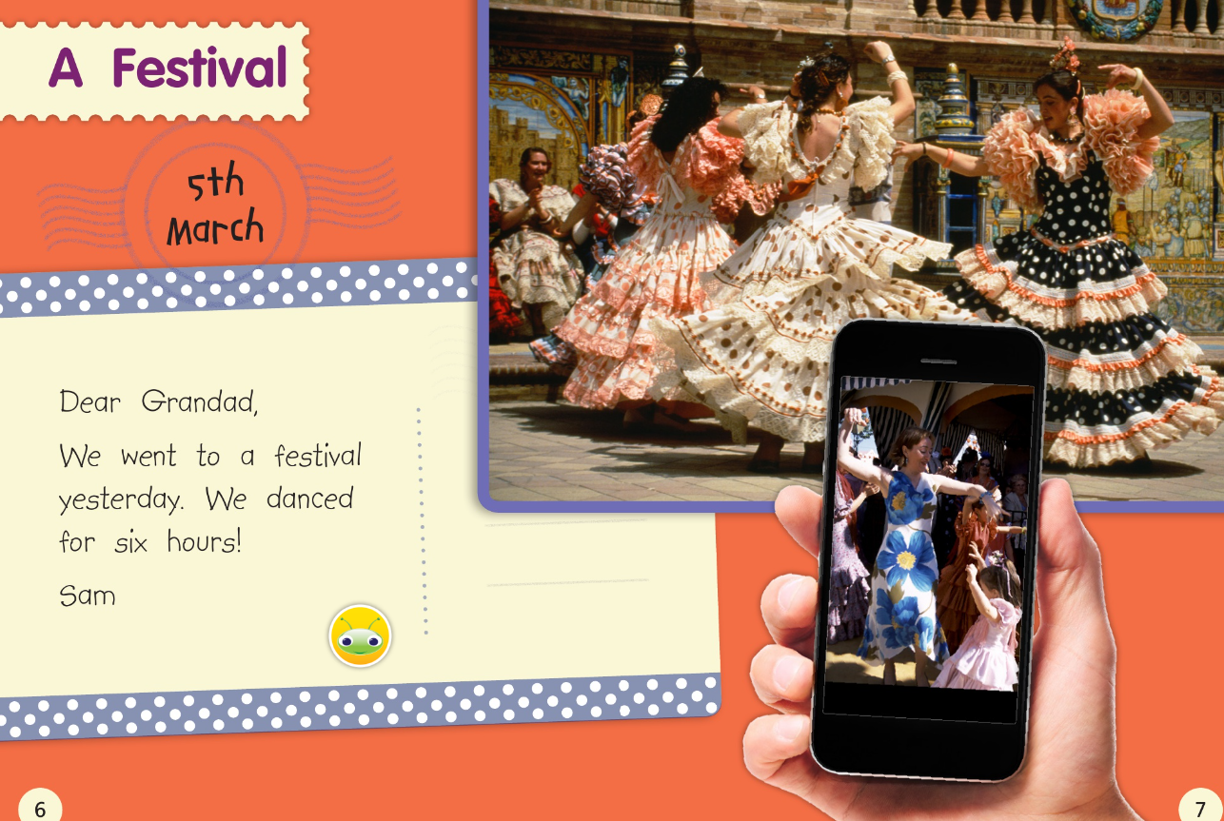

How long did they dance for?

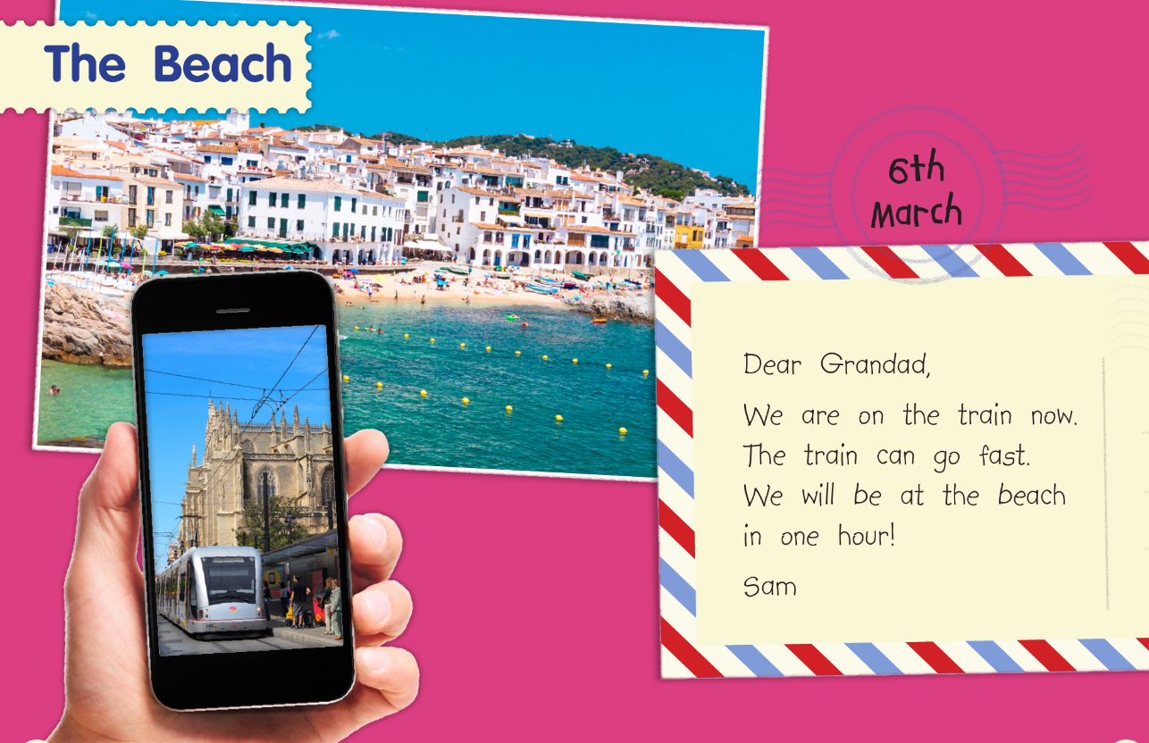

How are they travelling to the beach?
How long will it take to get there?
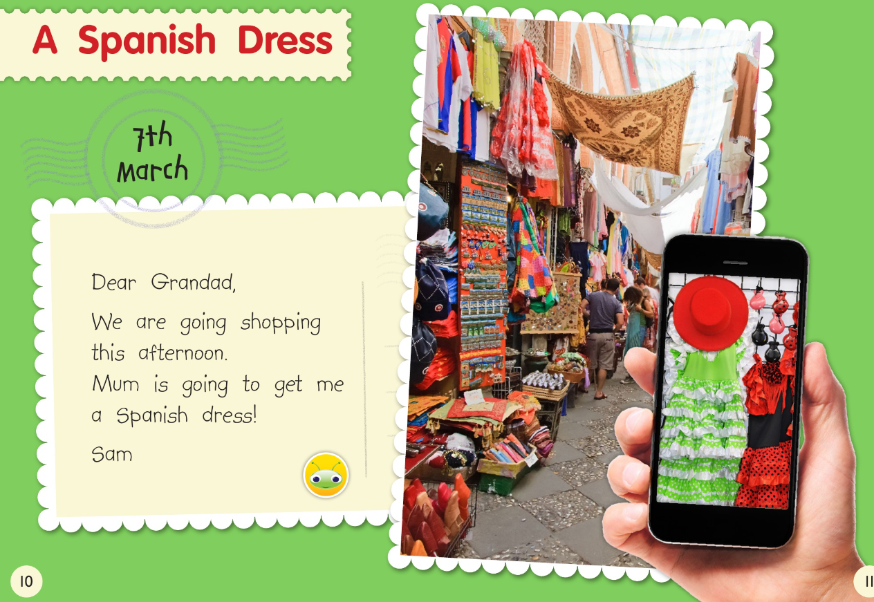

Who is going to buy Sam a dress?
What kind of dress is she going to get?
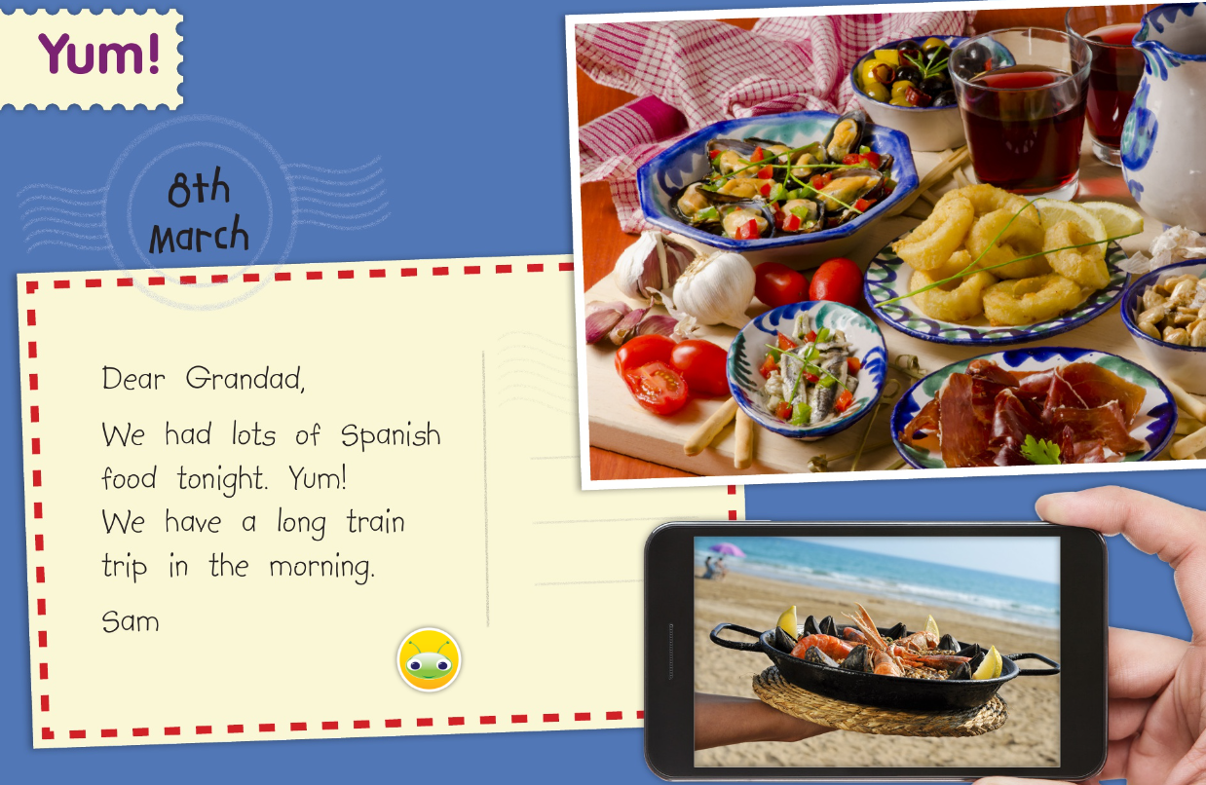

When is their train trip?
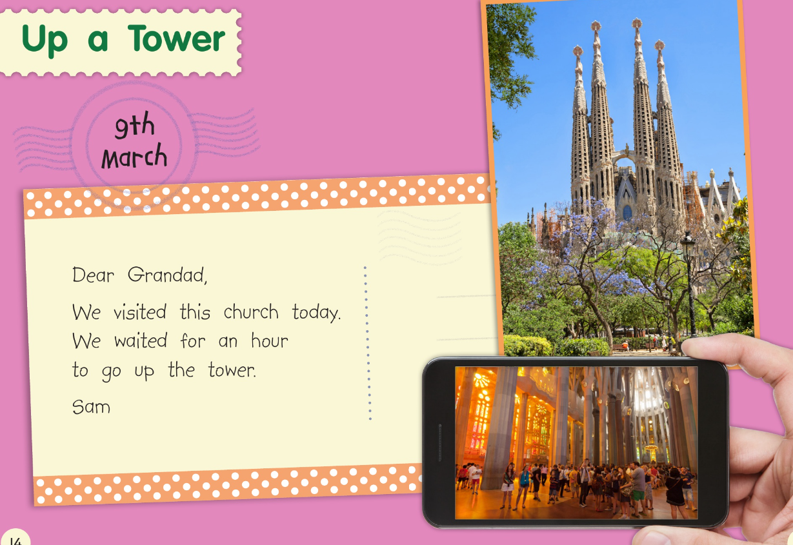

Where did they go today?

How long did they have to wait to go up the tower?
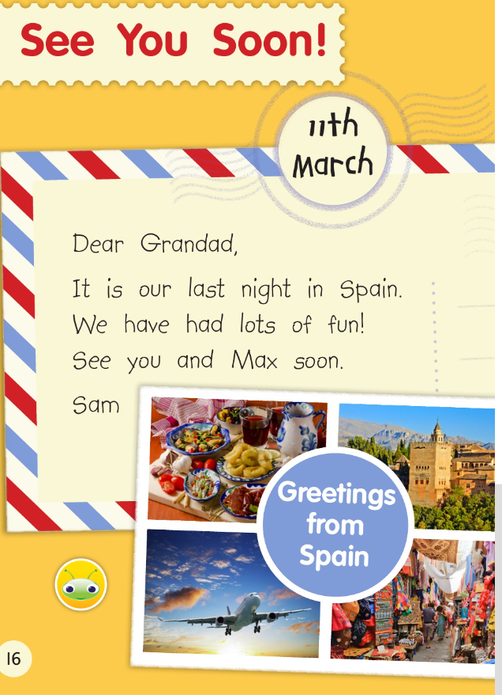

What date of their last night in Spain?

