 | Literacy – Reading and Writing. | Maths | Topic –
Monday | Share a story with your child this week we are looking at Pirates love underpants.  Discuss with your child what happens in the story. | - Water play – can you fill different sized containers – full, half full, empty, nearly full, almost empty.  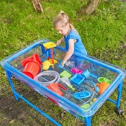 | Arts and crats-  Can you make your own treasure box using recycled materials e.g. a shoebox?  Could you decorate your treasure box using paint or collage materials?  Discuss with your family what treasure you would keep in your box.  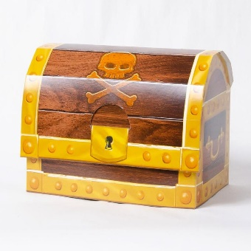
Tuesday | Can you design your own treasure map?  Can you draw a path, trees, birds and exciting Island?  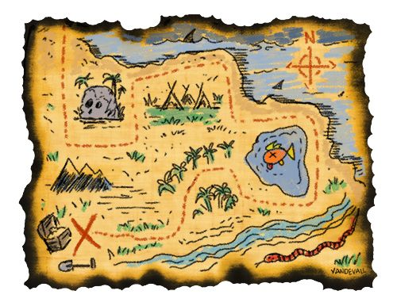 | Can you cut out 4,6, 10 gold coins?  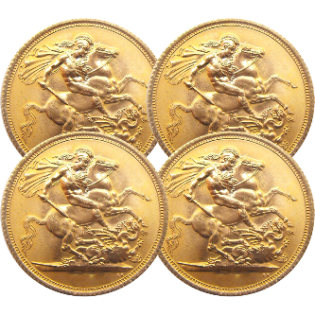
Wednesday | Can you design your own pirate flag using different patterns? | Can you create your own pirate ship using lego/blocks? | - UW Can you design and make your own boat? How many pirates would your pirate ship hold?
Thursday | Can you practise writing your name using chalk or in the sand?  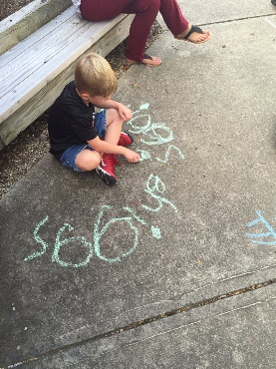 | Can you make your own pirate hat?  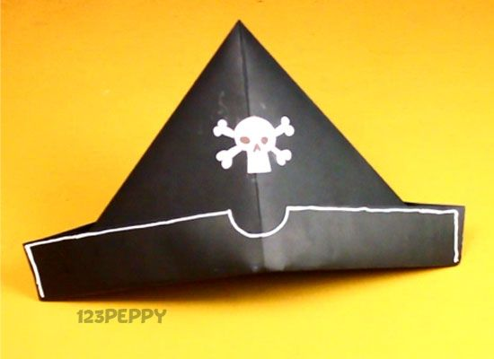 | - Play the game ‘Captains Coming.’  - Can you practise throwing and catching a ball?
Friday | Can you design your own telescope? Discuss with your family what you can see through your telescope.

