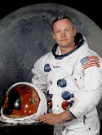
Neil Armstrong

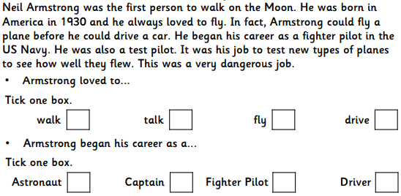
Read through the text and tick the correct answer for each question

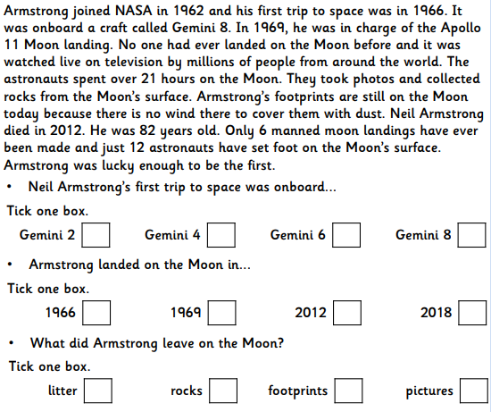

Answers
- Fly
- Fighter Pilot
- Gemini 8
- 1969
- Footprints

