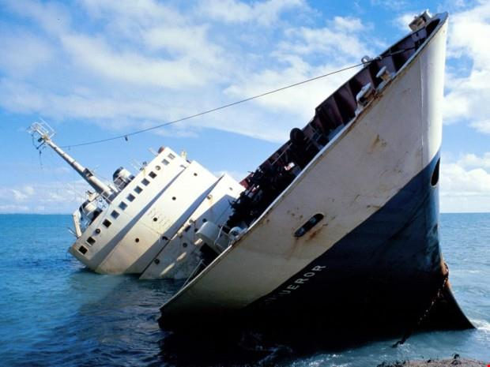
Today you are going to plan a story where you are a character on the sinking ship.

You have already come up with ideas about what might be happening, and how you might be feeling.

You can use bullet points to help you plan!

1st paragraph- what made the ship sink? Did something hit it? Did something cause an explosion?
E.g- the ship hit a huge ice berg. The lights started to flicker on and off. Everyone was screaming! I was petrified.
2nd paragraph- the ship starts to take on water. Where do you go? Do you start to search for things that might help you? Is there a life jacket that you could use?
E.g- Water started filling the ship. I desperately searched for something to help me. People were running in all directions! Suddenly I spotted something, a life jacket. I screamed with joy.

3rd Paragraph- It’s time to jump into the sea. Are you alone? Do you have anyone to help you? Are you sitting on some wood? Are you floating in the sea? How do you feel? Does something beneath the surface brush past your leg?

4th and final paragraph- The ending- what happens to you? Are you saved by a rescue boat? Do you manage to swim to safety? Do you have to race against a massive shark?

