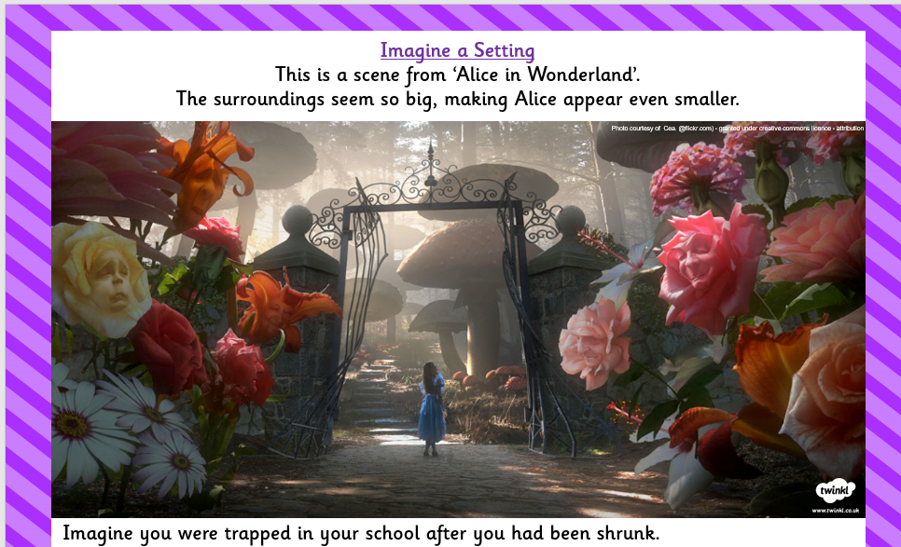

You are small. The surroundings are big. We know that small and big are BORING adjectives! How many other adjectives can you think of that mean the same as small and big?

