Have a look at the picture below
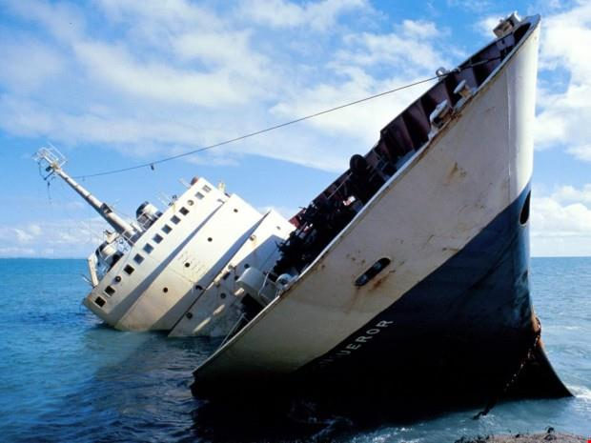

- What do you think is happening?
- Why might the ship be sinking?
- What could be in the water?
- Who could be on board the ship?
- How will they try to survive?
- Will there be any survivors?
Remember, answer the questions in full sentences. I think that…….

