Shipwreck
Day 1- Expanded noun phrases
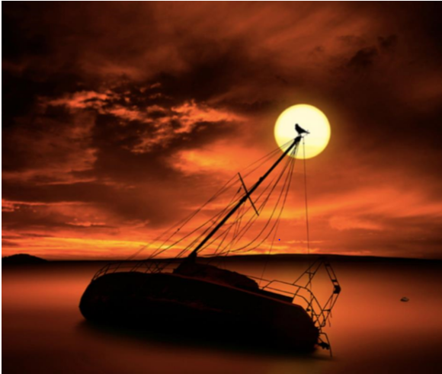
Task-Today you will be using expanded noun phrases to describe the shipwreck. Describe each part.
E.g. The blood-red sky
sky
ship
moon
sea
bird

