Day 4-The Visitor
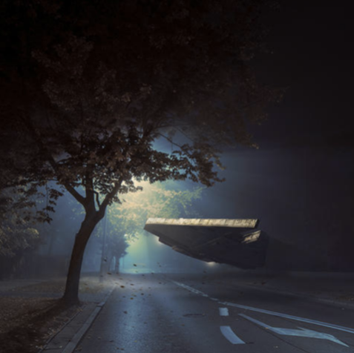

Task: Can you write a diary entry from the moment you saw this old ship on the road.

Dear diary,
It was the middle of the night when they came.
A typical autumn evening, there was a scattering of fallen, auburn leaves on the highway. Light leaked from a flickering streetlamp, which buzzed faintly as the light bulb struggled.
The wind moaned quietly, and the leaves crackled as they rose and fell making me feel uneasy.
A humming noise was the first sign of their arrival. In the distance at first, then filling the street as it came closer. It hovered several feet from the road, tilting slightly from side to side as if surveying the land around.

