Day 4
Today you will be writing your non chronological report on the Romans. Remember to:
-Write in paragraphs.
-Use sub-headings
-Written in past tense.
-Written in a formal tone.

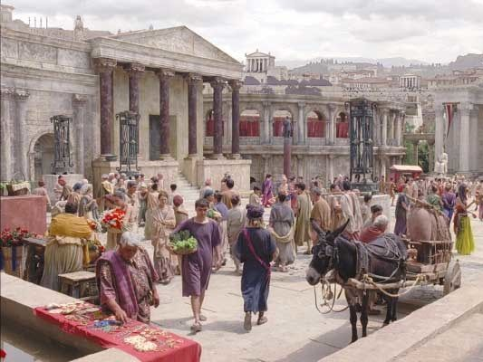
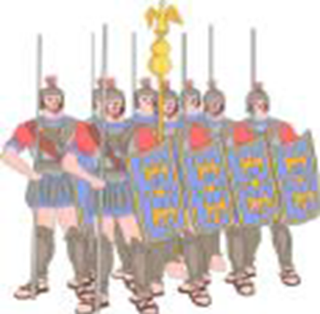
Roman army

Roman lifestyle

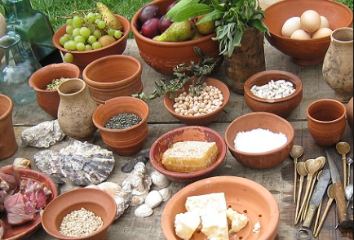
Roman food

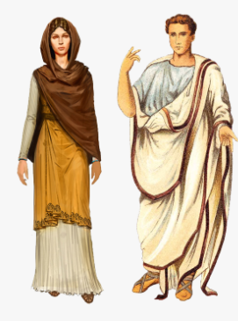
Roman clothes

Roman homes.
