Colours of the ocean-To write a description
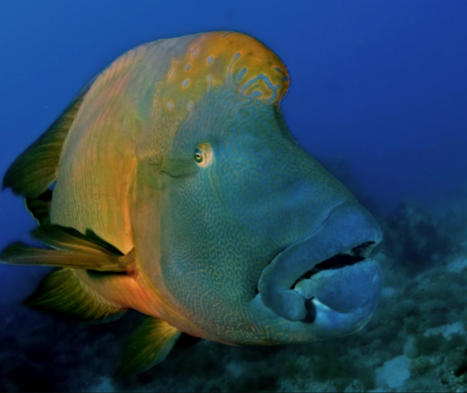
- Today you will be writing a description of the fish and the surroundings. Use the below description to help you start. You may magpie these ideas.
- The majestic creature glided through the perfect, azure waters. Its size and beautiful colours stood out in stark contrast to the murky, grey ocean floor beneath.

