The Lego story-To write a chronological report
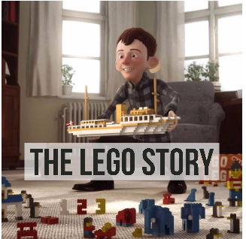
https://www.youtube.com/watch?reload=9&v=NdDU_BBJW9Y&t=2s
Today you will use your notes to write your chronological report up. Remember it needs to be in time order, include facts and you may want to include pictures too. Make sure to include time connectives and relative clauses in your writing . Remember to think of other words for Lego, so you are not repeating yourselves. E.g. building block, construction toy, plastic bricks.

