Watch the clip: https://www.youtube.com/watch?v=_uG3VHR8aVI
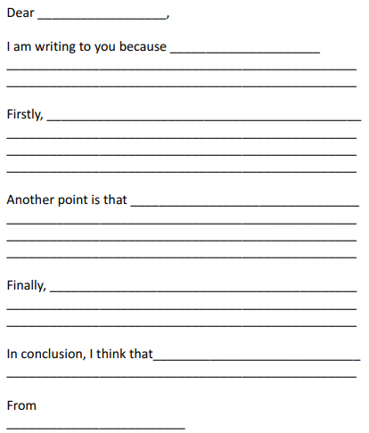
Task- Use your ideas from Day 1 to fill in the blanks to this letter. First you need to decide if you think he should or shouldn’t pull the rope. You are allowed to use everything you know after watching the full clip!

