The Outdoors
Today you are going to write about what you can see, hear, smell and feel.
What can you see in your garden? (If you cannot go outside then think about what you have seen when you have been outdoors).

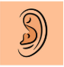
e.g., birds chirping, cars zooming past.

