The lighthouse-To use formal language
https://www.literacyshed.com/the-lighthouse.html
What is formal language?
It is the language we use in professional, official and impersonal situations. It is used when we need to be serious, when we don’t know our audience personally and when the topic is of importance. Can you come up with ideas for when formal language would be important? What do we think the features are? There are no contractions, colloquialisms, idioms or clichés. It avoids the first person, uses the passive voice more often, it uses precise language, statistics are often used, it uses Standard English and is often made up of complex sentences.
E.g.
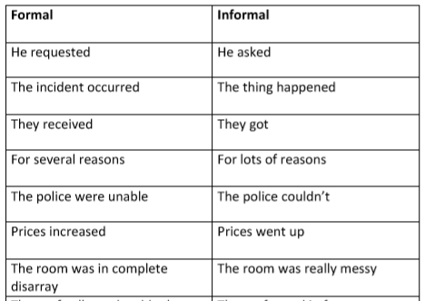

Task-Look closely at the letters. Change them to formal.
