Magic carpet ride
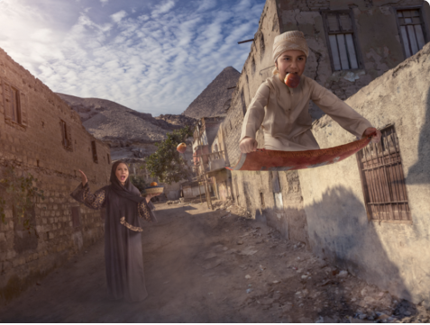

You will be writing a story about this picture above. So now it is time to plan it. Below are a few questions to help you.

Who are the characters involved?
Where is this boy going?
Is he going to do something good or bad?
Where will his magic carpet lead him?

*Use direct speech in your writing. Remember how would your characters be saying it?
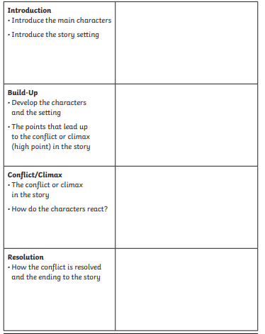
Use this template to help you plan your story!

