-You will be writing a diary entry from one of the children’s point of view in the boat. REMEMBER put yourselves in their shoes.

Time connectives you will use:

Fronted adverbials you will use:

What has happened?
_________________________________________________________________________________________________________________________________________________________________________________________________________________________________________________________________________________________________________________________________________________________________________________________________

How did you feel?
_________________________________________________________________________________________________________________________________________________________________________________________________________________________________________________________________________________________________________________________________________________________________________________________________

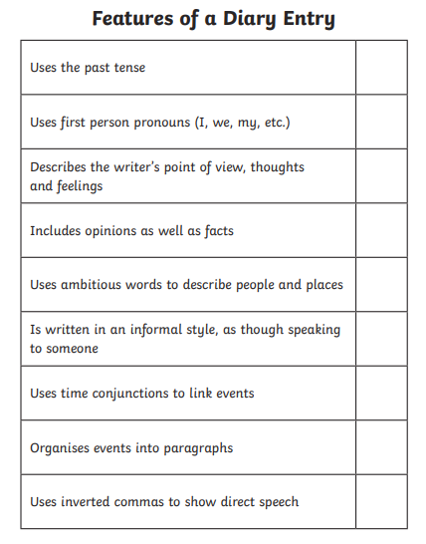
I have attached features of a diary entry; make sure you include these in your plan.

