Day 3
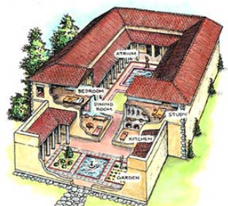
Today you will be researching Roman homes.
-What did rich Romans houses look like?
-What did the poorer houses look like?
-What materials did they use to make the house?
-Who helped build the houses?

Now put all your information that you researched over the last few days together.

