Day 3- Get planning
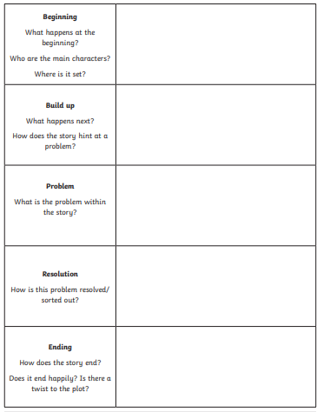
You will be planning your story today about Astrid and her magic!

