Day 3- The Clock Tower
Task- Can you use the conjunction ‘but’ to describe how the setting changes?
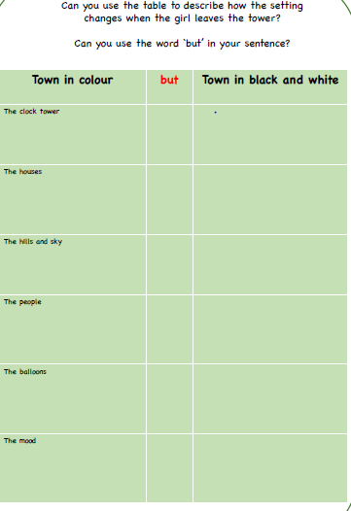
Word Bank- sad, lonely, grey, depressing, sorrowful, boring, still, quit, miserable, empty, silent, frozen, dark, unhappy, eerie, peaceful

