Seasons

We are going to be learning about seasons this week.
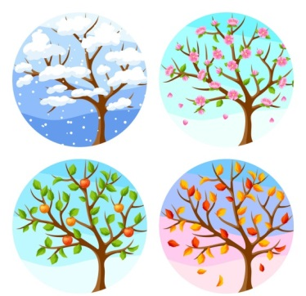

Watch this video: https://www.bbc.co.uk/bitesize/topics/zkvv4wx/articles/zcx3gk7

You need to use the information in the video and write down 2 sentences for each season. You can watch the video as many times as you like.

Remember our rules for writing a sentence:
- Think of your sentence.
- Practise saying your sentence aloud until you can remember it.
- Write your sentence down. Remember to Fred talk each word.
- Start your sentence with a capital letter.
- Finger spaces between every word.
- A full stop at the end.
- Read over your sentence to check it makes sense.

