Adjectives

This week we are going to use continue using adjectives in our writing to make it more interesting.
Parent help video https://www.bbc.co.uk/bitesize/topics/zrqqtfr/articles/zy2r6yc
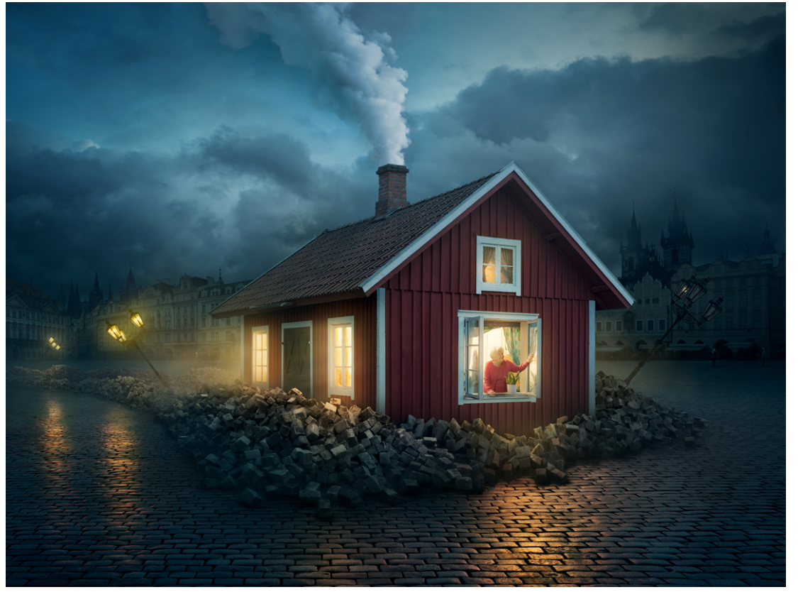

Use adjectives to describe what you can see in the picture; e.g., thick, white smoke.

