Character description
Remember reading ‘George’s Marvellous Medicine’ this week you will be writing a character description on Grandma.
Grizzly, old grunion
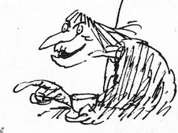

Draw an image similar to this and use what you remember and in the internet to find Roald Dahl’s vivid description of George’s grandmother

