**Day 2- The Visitor**

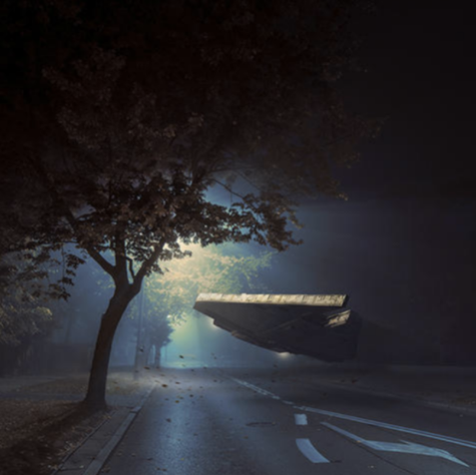

This ship has randomly come onto the street.

Can you draw a picture of where you think the ship has come from?

Send me a picture of your finished piece ☺