Day 2- Identify Relative Clauses
Revise Relative clauses by reading the card below and highlight examples in the text.
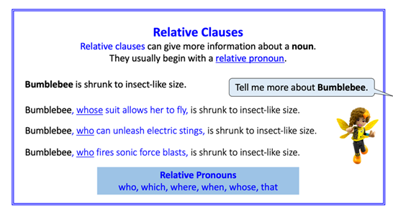

Superheroes
Highlight the relative pronouns and relative clauses. The first two have been done for you.

Wonder Woman

She is a founding member of the Justice League whose members also include Superman and Batman. Her mother, who is Queen Hippolyta, sculpted her from clay.
Her true home is Themysira where she is a princess. Her other name, which is used when she is in America, is Diana Prince.
The equipment, that she possesses, includes a lasso of truth and a pair of indestructible bracelets.

Batman

His secret identity, which he does not reveal, is Bruce Wayne. Bruce Wayne is extremely wealthy and lives in Wayne Manor which is on the outskirts of Gotham City. Batman fights crime in Gotham City. His parents, whose death he witnessed, were Dr Thomas Wayne and Martha Wayne. His suit, which he wears on missions, provides him with protection and makes him easily identifiable. His worst enemy is the Joker who has the appearance of a clown.
Relative pronouns
which, who, where, when, whose, that

