Biography of Charles Dickens-To create a timeline of events
https://www.literacyshed.com/charlesdickens.html

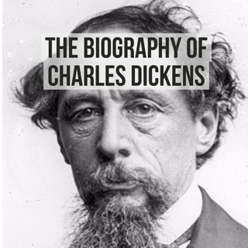
From last lesson, you will have discovered Charles Dickens was a famous author. He wrote famous novels including Oliver Twist and A Christmas Carol. Today you will be using a timeline to place the events in his life. I have included a template below to help you. This will help you plan your non-chronological report.

