Day 2- The Clock Tower
Task- Look at the contrasting pictures. Can you describe the difference? Choose one set of images or do both.
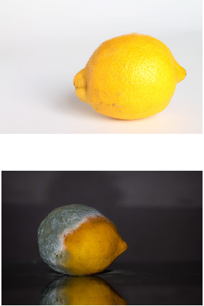
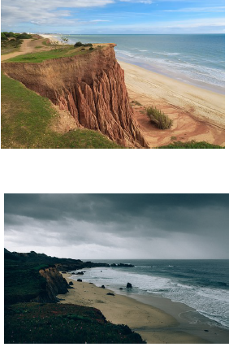

Before | After

