Tuesday- David Weisner
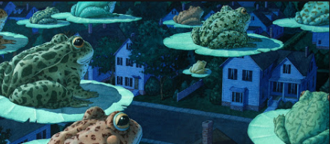
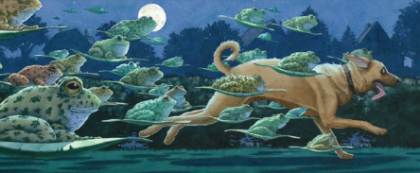

You read this book in Year 3, familiarise yourself with the story with the attached PowerPoint.

Answer the following questions:
- Why do you think the book is called Tuesday?

- How are the frogs flying?

- Whose house do they end up going to?

- What do you think was on the TV that they were interested in?

