Day 1-To retrieve and infer
https://www.literacyshed.com/ruin.html
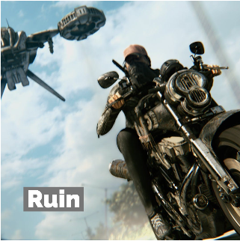
Watch the video using the link above.
This hyper realistic short animation is set in a post-apocalyptic landscape of derelict buildings which are slowly being taken over by the futuristic flora and fauna.

Key questions:
- When is this story set? How do we know?
- What do you think has happened?
- How did one man survive or are there more?
- What is trying to stop him and why?
- What will happen next?

