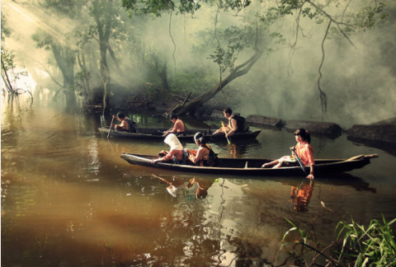
Journey to School

1.) Where do you think they are? What country might it be?

2.) How long do you think it takes them to get to school?

3.) What time is it in the picture?

4.) What do you think they all had for breakfast?

5.) What do they have inside their rucksacks?

5.) Where are their parents?

6.) Are the children happy?

