Day 1
This week your focus will be on writing a non-chronological report on the Romans. You will be researching different aspects of their lives. You will then be writing a paragraph on each section and ending up with a non-chronological report.

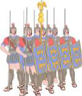
To begin with you will be researching The Roman Army (complete this in bullet points)

-Who were the Roman army?
-Which battles did they have?
-What did it take to be a Roman soldier?
- How did they protect themselves from the enemy?

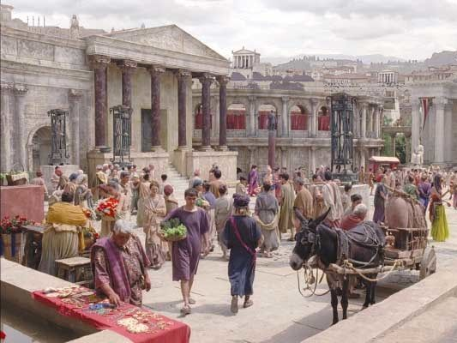
Next you will research on Roman Lifestyle
-Did the children go to school?
-What jobs would the men do?
-What would the women do?
-What did they do for hobbies?

