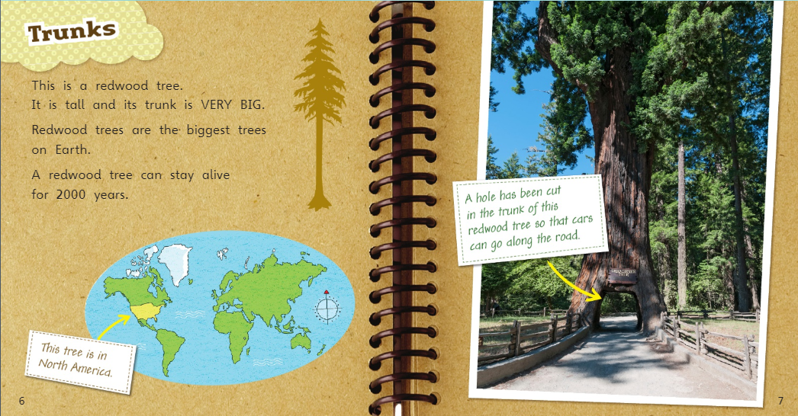

How long can a redwood tree stay alive?

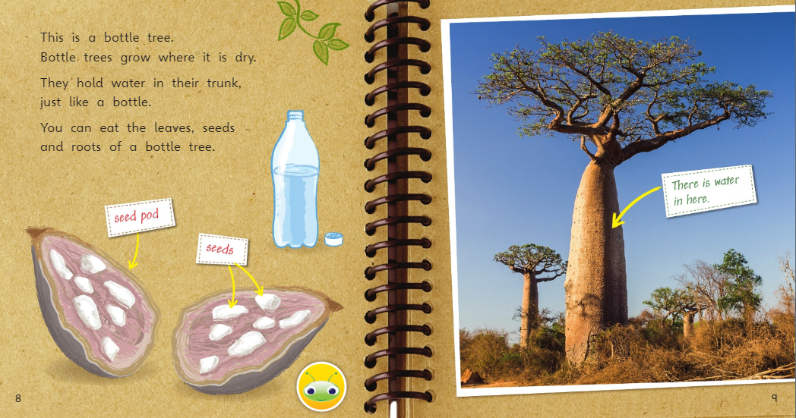

Where do bottle trees grow?

Where do they hold their water?

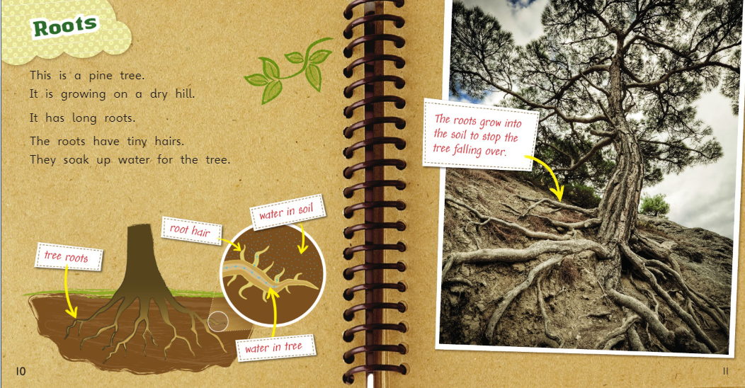

Why do the roots grow into the soil?

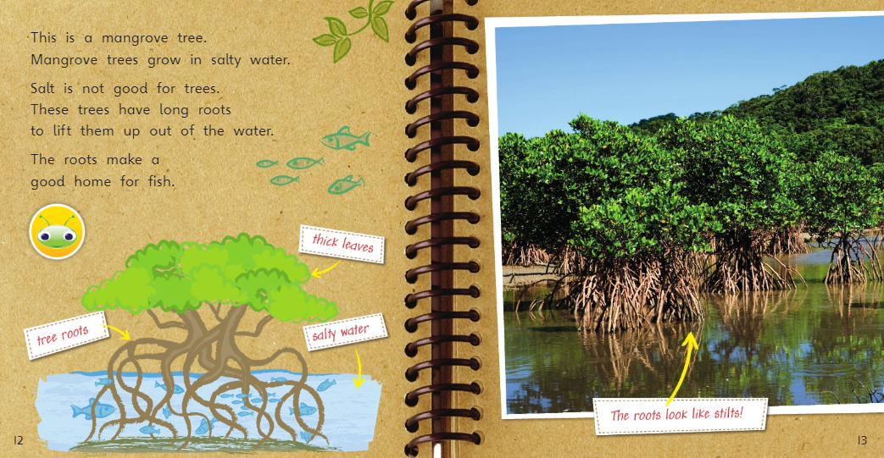

What kind of water do Mangrove trees grow in?

Why do Mangrove trees have long roots?
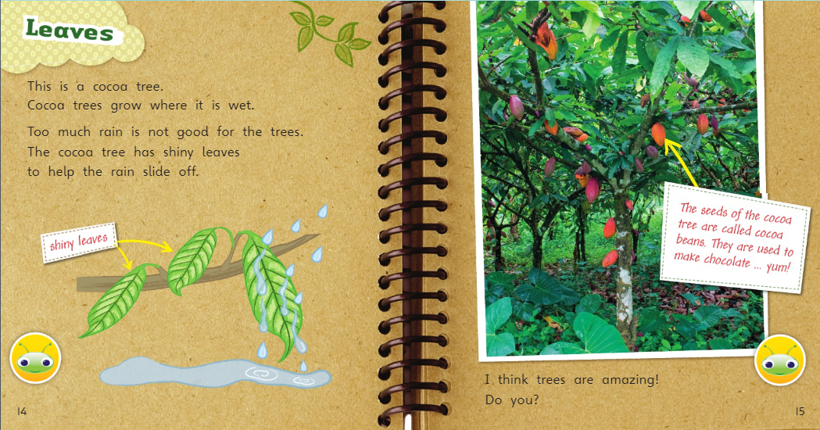

Where do Cocoa trees grow?
Why do they have shiny leaves?
What are cocoa beans used to make?

