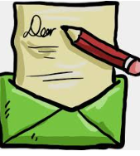
A Letter to Tim Peake

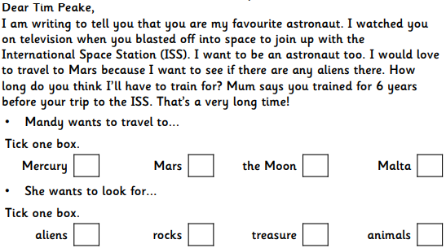
Read through the text and tick the correct answer for each question.

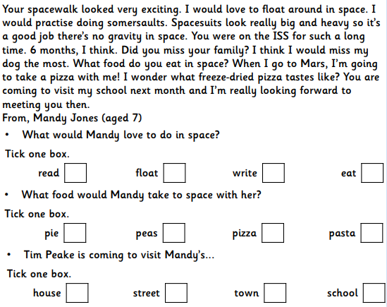

Answers
- Mars
- Aliens
- Float
- Pizza
- School

